**University of Michigan – Dearborn**

**Department of Computer and Information Science**

**CIS 150L – Fall 2014**

Final Project

Srinivas Simhan

12/01/14

**Table of Content**

1. Final Source Code 3
   1. Final Source Code with Console Output 3
   2. Console Output Screenshot 7
   3. Final Source Code with Text File Output 7
   4. Text File Output Screenshot 11
2. Software System Design 13
   1. Diagram 13
3. Software Testing Table 13
   1. Testing Table 13
4. Screenshots 14
   1. Step-by-Step Process (Console Output) 14
5. Extra Credit 1: Results in Output File 67
   1. How? (Code Included) 67
6. Extra Credit 2: Read Answer Key String from a Text File Instead of as a Constant String 67
   1. How? (Code Included) 67
7. Extra Credit 3: Enter Name of File that Contains Students’ Answers 68
   1. How? (Code Included) 68
8. **Final Source Code**
   1. **Final Source Code with Console Output**

// Purpose: Final Project (with Console Output)

// Author: Srinivas Simhan

// Creation Date: 12/01/14

// Last Modification Date: 12/01/14

#include <iostream>

#include <fstream>

#include <string>

#include <cmath>

using namespace std;

float computeCount(string);//function to compute the number of characters using the answer key string

float computeScore(string, int); //function to compute the score using the answer key string

char determineGrade(float); //function to determine the letter grade using the float score value

void instructions(); //instructions for using the program

void ending(); //closing remarks after using the program

//List of Global Variables (int, float, const string)

int j = 0;

int students = 0;

float max = -1;

float min = 100;

//float NB_QUESTIONS = 20;

//const string ANSWER_KEY = "abcdefabcdefabcdefab";

ofstream outFile("output.txt");

int main()

{

string id, answers;

char letterGrade;

float score1;

float count;

float average = 0;

instructions();

//disable following 3 lines if necessary to use the float NB_QUESTIONS = line

float NB_QUESTIONS;

count = computeCount(answers); // function to count characters = int count

NB_QUESTIONS = count;

string fileName;

cout << "Enter file name" << endl;

cin >> fileName;

ifstream key;

key.open(fileName + ".txt"); //answers

while (!key.eof())

{

key >> id;

cout << endl << "Student: " << (j + 1) << endl;

key >> answers;

j = j + 1;

score1 = computeScore(answers, count); //function to calculate score = score

average = average + score1;

students++;

letterGrade = determineGrade(score1);

if (score1 >= max)

max = score1;

else

max = max;

if (score1 <= min)

min = score1;

else

min = min;

for (int i = 0;

i < j;

i++)

{

cout << "ID: " << id << endl;

cout << "Answers: " << answers << endl;

cout << "Score: " << score1 << "%" << endl;

cout << "Grade: " << letterGrade << endl << endl << endl;

i = i + j;

}

}

average = average / students;

cout << "A total of " << students << " student answers have been processed." << endl;

cout << "Statistics: " << endl;

cout << "Average Score: " << average << "%" << endl;

cout << "Minimum Score: " << min << "%" << endl;

cout << "Maximum Score: " << max << "%" << endl;

cout << "Character Count: " << count << endl << endl;

ending();

cout << "Please check output file." << endl << endl;

system("pause");

return 0;

}

// Purpose: This function counts the number of characters in a given string

// Author: Srinivas Simhan

// Creation Date: 12/01/14

// Last Modification Date: 12/01/14

float computeCount(string answers)

{

int count = 0;

string ANSWER_KEY;

ifstream student;

student.open("answerString.txt");

student >> ANSWER_KEY;

for (int i = 0; i < ANSWER_KEY.length(); i++)

{

count++;

}

return count;

}

// Purpose: This function compares answer to ANSWER_KEY to get score

// Author: Srinivas Simhan

// Creation Date: 12/01/14

// Last Modification Date: 12/01/14

float computeScore(string answers, int NB_QUESTIONS)

{

string ANSWER_KEY;

ifstream student;

student.open("answerString.txt");

while (!student.eof())

{

student >> ANSWER_KEY;

float score;

int correct = 0;

for (int i = 0;

i < NB_QUESTIONS;

i++)

{

if (ANSWER_KEY.at(i) == answers.at(i))

{

correct++;

}

}

score = (correct * 100) / NB_QUESTIONS;

return score;

}

}

// Purpose: This function returns the letter grade for the given score

// Author: Srinivas Simhan

// Creation Date: 12/01/14

// Last Modification Date: 12/01/14

char determineGrade(float score1)

{

char grade;

if (score1 >= 90)

grade = 'A';

else if (score1 < 90 && score1 >= 80)

grade = 'B';

else if (score1 < 80 && score1 >= 70)

grade = 'C';

else if (score1 < 70 && score1 >= 60)

grade = 'D';

else if (score1 < 60 && score1 >= 50)

grade = 'E';

else if (score1 < 50)

grade = 'F';

return grade;

}

// Purpose: Gives you directions about what the program does and how to use it

// Author: Srinivas Simhan

// Creation Date: 12/01/14

// Last Modification Date: 12/01/14

void instructions()

{

cout << "********************************************************************************" << endl;

cout << "DIRECTIONS:" << endl;

cout << "Welcome! This program enters the Student ID for each student from a file. Then " << endl;

cout << "it puts in each student's answers from the file from the multiple choice exam. " << endl;

cout << "Finally, the program compares the answers to an answer key and determines the " << endl;

cout << "letter and percent grade on the exam for each student in the file." << endl;

cout << endl;

cout << "It will also list Statistics about the scores calculated." << endl;

cout << "********************************************************************************" << endl << endl;

}

// Purpose: Thanks you for using the program

// Author: Srinivas Simhan

// Creation Date: 12/01/14

// Last Modification Date: 12/01/14

void ending()

{

cout << "********************************************************************************" << endl;

cout << "I hope everything went well. Thank you for using this program!" << endl;

cout << "********************************************************************************" << endl;

}

* 1. **Console Output Screenshot**

**Console:**

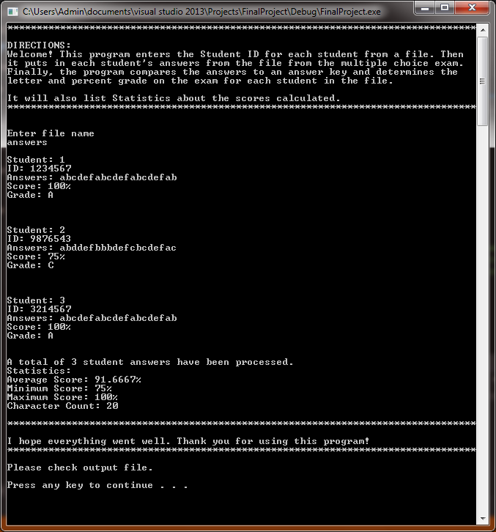

* 1. **Final Source Code with Text File Output**

// Purpose: Final Project (with Text File Output)

// Author: Srinivas Simhan

// Creation Date: 12/01/14

// Last Modification Date: 12/01/14

#include <iostream>

#include <fstream>

#include <string>

#include <cmath>

using namespace std;

float computeCount(string);//function to compute the number of characters using the answer key string

float computeScore(string, int); //function to compute the score using the answer key string

char determineGrade(float); //function to determine the letter grade using the float score value

void instructions(); //instructions for using the program

void ending(); //closing remarks after using the program

//List of Global Variables (int, float, const string)

int j = 0;

int students = 0;

float max = -1;

float min = 100;

//float NB_QUESTIONS = 20;

//const string ANSWER_KEY = "abcdefabcdefabcdefab";

ofstream outFile("output.txt");

int main()

{

string id, answers;

char letterGrade;

float score1;

float count;

float average = 0;

instructions();

//disable following 3 lines if necessary to use the float NB_QUESTIONS = line

float NB_QUESTIONS;

count = computeCount(answers); // function to count characters = int count

NB_QUESTIONS = count;

string fileName;

cout << "Enter file name: " << endl;

cin >> fileName;

ifstream key;

key.open(fileName + ".txt"); //answers

while (!key.eof())

{

key >> id;

outFile << endl << "Student: " << (j + 1) << endl;

key >> answers;

j = j + 1;

score1 = computeScore(answers, count); //function to calculate score = score

average = average + score1;

students++;

letterGrade = determineGrade(score1);

if (score1 >= max)

max = score1;

else

max = max;

if (score1 <= min)

min = score1;

else

min = min;

for (int i = 0;

i < j;

i++)

{

outFile << "ID: " << id << endl;

outFile << "Answers: " << answers << endl;

outFile << "Score: " << score1 << "%" << endl;

outFile << "Grade: " << letterGrade << endl << endl << endl;

i = i + j;

}

}

average = average / students;

outFile << "A total of " << students << " student answers have been processed." << endl;

outFile << "Statistics: " << endl;

outFile << "Average Score: " << average << "%" << endl;

outFile << "Minimum Score: " << min << "%" << endl;

outFile << "Maximum Score: " << max << "%" << endl;

outFile << "Character Count: " << count << endl << endl;

ending();

cout << "Please check output file." << endl << endl;

system("pause");

return 0;

}

// Purpose: This function counts the number of characters in a given string

// Author: Srinivas Simhan

// Creation Date: 12/01/14

// Last Modification Date: 12/01/14

float computeCount(string answers)

{

int count = 0;

string ANSWER_KEY;

ifstream student;

student.open("answerString.txt");

student >> ANSWER_KEY;

for (int i = 0; i < ANSWER_KEY.length(); i++)

{

count++;

}

return count;

}

// Purpose: This function compares answer to ANSWER_KEY to get score

// Author: Srinivas Simhan

// Creation Date: 12/01/14

// Last Modification Date: 12/01/14

float computeScore(string answers, int NB_QUESTIONS)

{

string ANSWER_KEY;

ifstream student;

student.open("answerString.txt");

while (!student.eof())

{

student >> ANSWER_KEY;

float score;

int correct = 0;

for (int i = 0;

i < NB_QUESTIONS;

i++)

{

if (ANSWER_KEY.at(i) == answers.at(i))

{

correct++;

}

}

score = (correct * 100) / NB_QUESTIONS;

return score;

}

}

// Purpose: This function returns the letter grade for the given score

// Author: Srinivas Simhan

// Creation Date: 12/01/14

// Last Modification Date: 12/01/14

char determineGrade(float score1)

{

char grade;

if (score1 >= 90)

grade = 'A';

else if (score1 < 90 && score1 >= 80)

grade = 'B';

else if (score1 < 80 && score1 >= 70)

grade = 'C';

else if (score1 < 70 && score1 >= 60)

grade = 'D';

else if (score1 < 60 && score1 >= 50)

grade = 'E';

else if (score1 < 50)

grade = 'F';

return grade;

}

// Purpose: Gives you directions about what the program does and how to use it

// Author: Srinivas Simhan

// Creation Date: 12/01/14

// Last Modification Date: 12/01/14

void instructions()

{

outFile << "********************************************************************************" << endl;

outFile << "DIRECTIONS:" << endl;

outFile << "Welcome! This program enters the Student ID for each student from a file. Then " << endl;

outFile << "it puts in each student's answers from the file from the multiple choice exam. " << endl;

outFile << "Finally, the program compares the answers to an answer key and determines the " << endl;

outFile << "letter and percent grade on the exam for each student in the file." << endl;

outFile << endl;

outFile << "It will also list Statistics about the scores calculated." << endl;

outFile << "********************************************************************************" << endl << endl;

}

// Purpose: Thanks you for using the program

// Author: Srinivas Simhan

// Creation Date: 12/01/14

// Last Modification Date: 12/01/14

void ending()

{

outFile << "********************************************************************************" << endl;

outFile << "I hope everything went well. Thank you for using this program!" << endl;

outFile << "********************************************************************************" << endl;

}

* 1. **Text File Output Screenshot**

**Console:**

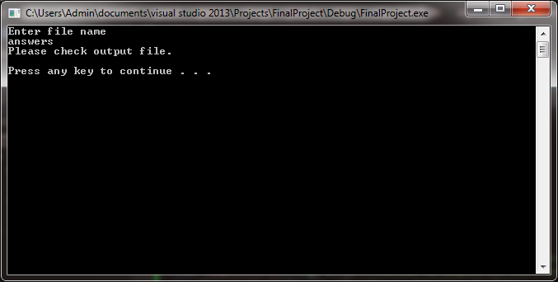

**Text File:**

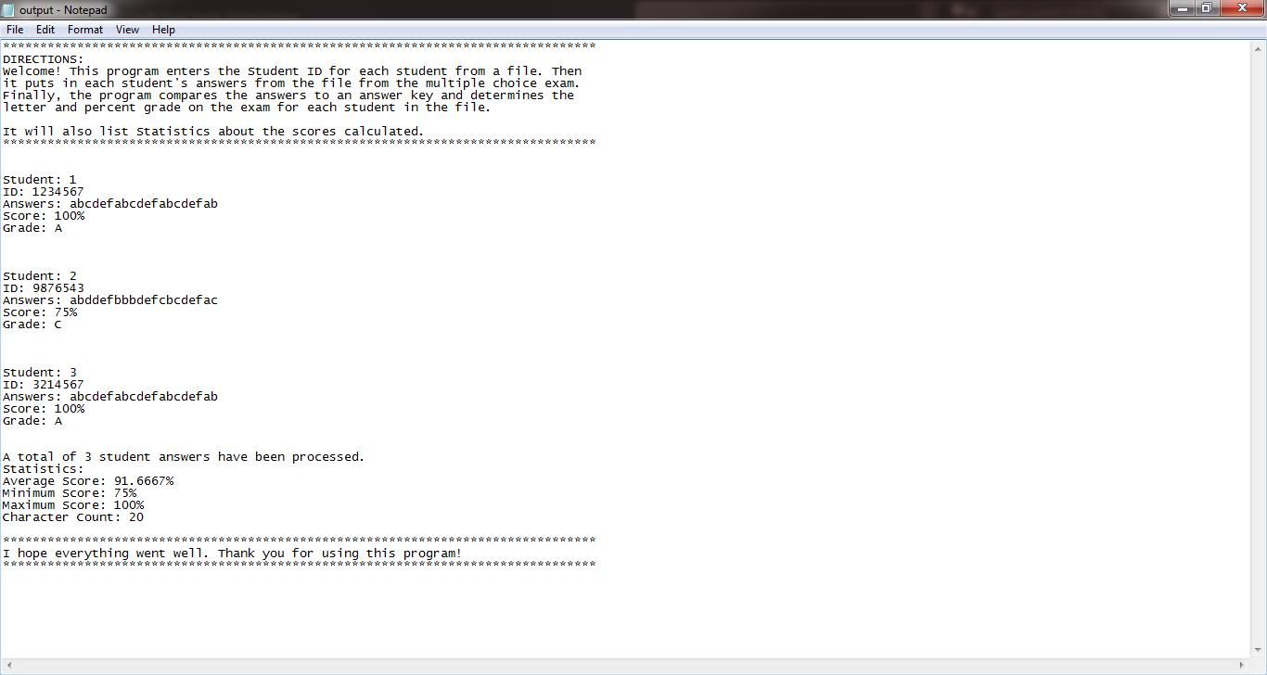

1. **Software System Design**

**2.1 Diagram**

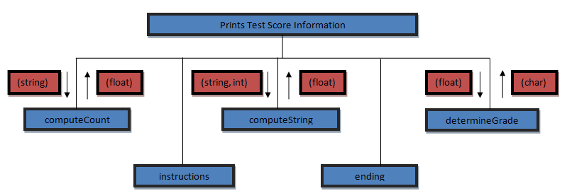

1. **Software Testing Table**

**3.1 Testing Table**

|  |  |  |  |
| --- | --- | --- | --- |
| **Reason for Test Table** | **Input Values** | **Expected Output** | **Observed Output** |
| **Test with 20 given answers in the Answer Key.** | **Type in “answers”** | **It will display the results as it is asked to.** |  |
| **Test with 21 given answers in the Answer Key.** | **Type in “answers”** | **It will provide an error because there aren’t enough student answers in the “answers.txt” file** |  |
| **Test with 19 answers in the Answer Key.** | **Type in “answers”** | **It will give extra credit to student 2.** |  |

1. **Screenshots**

**4.1 Step-by-Ste Step-by-Step Process (Console Output)**

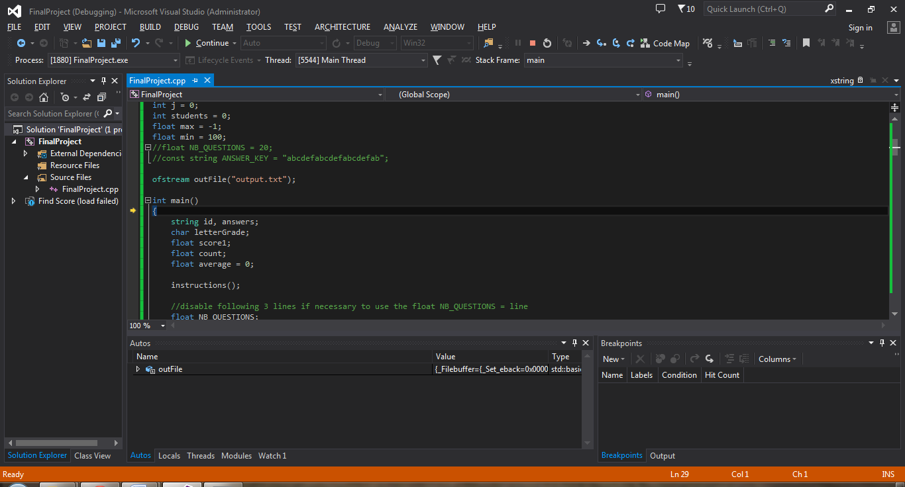

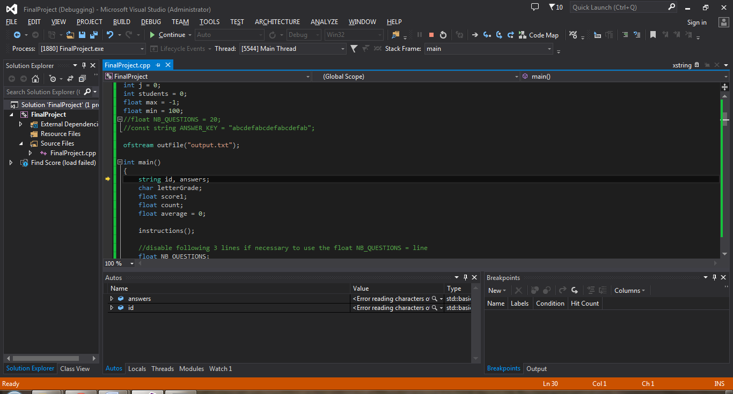

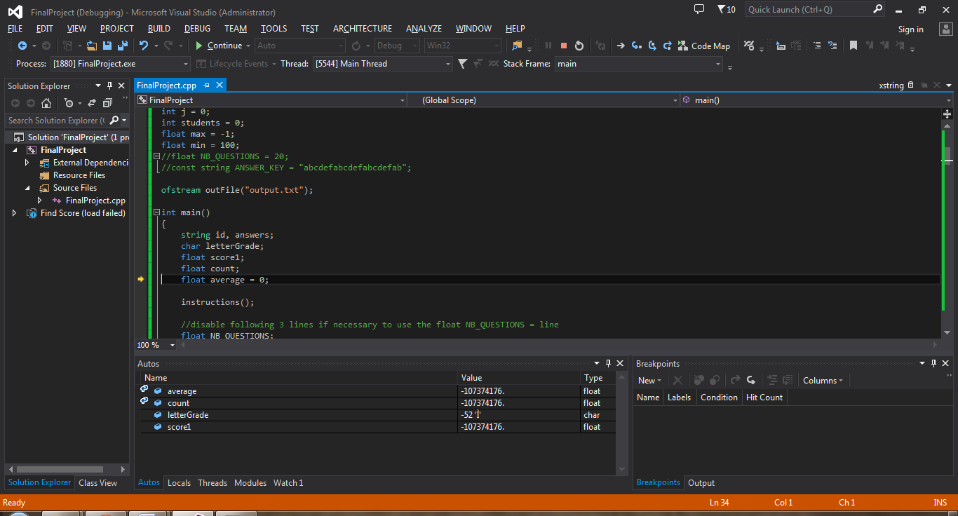

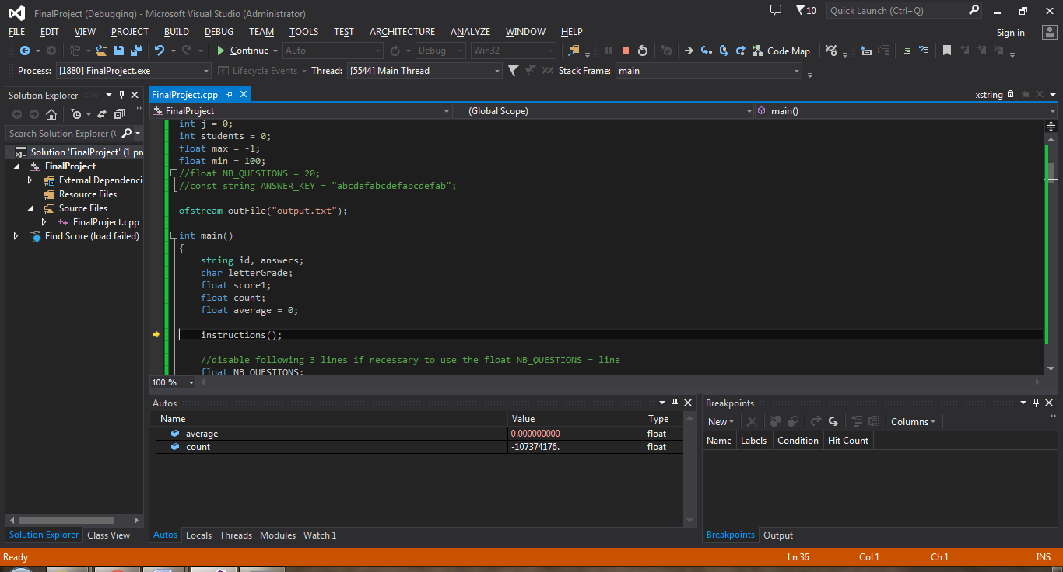



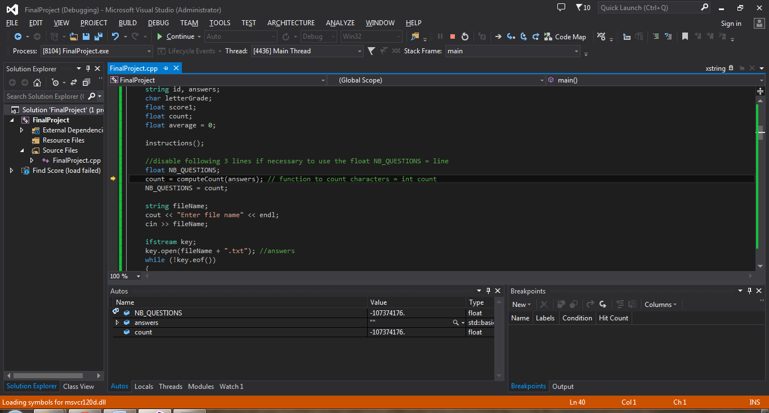

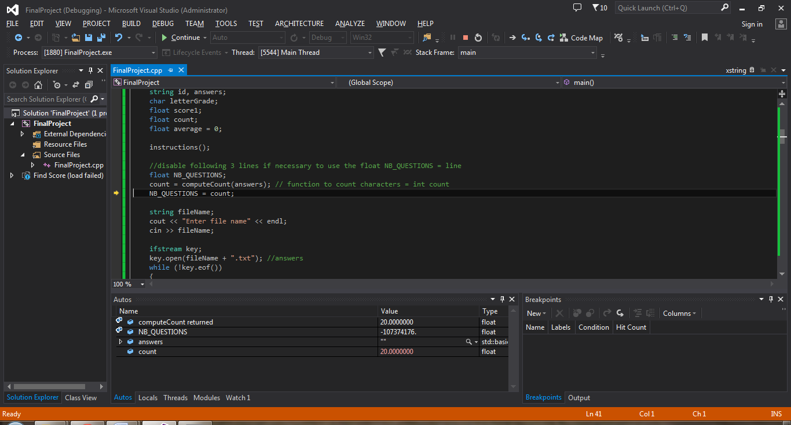

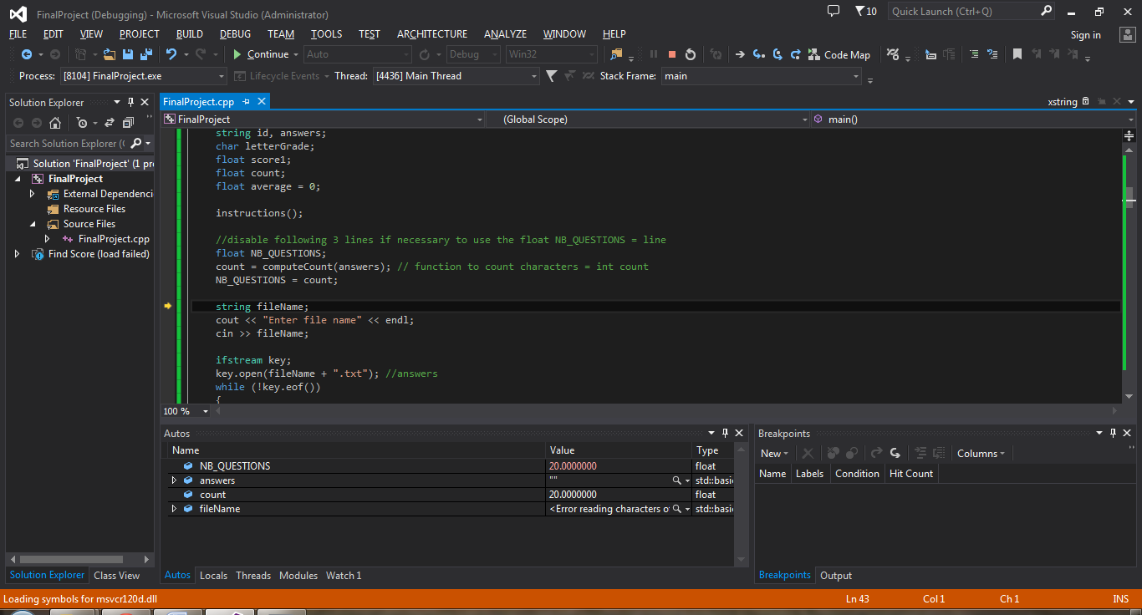

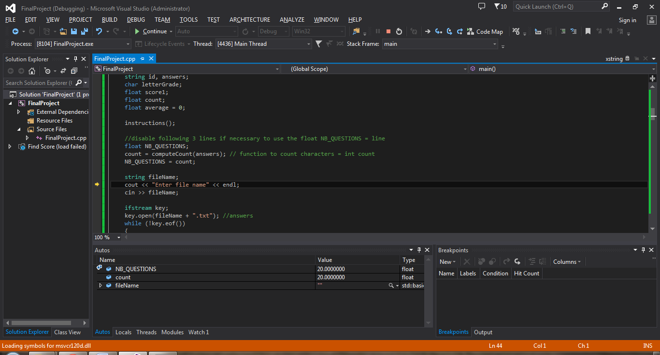

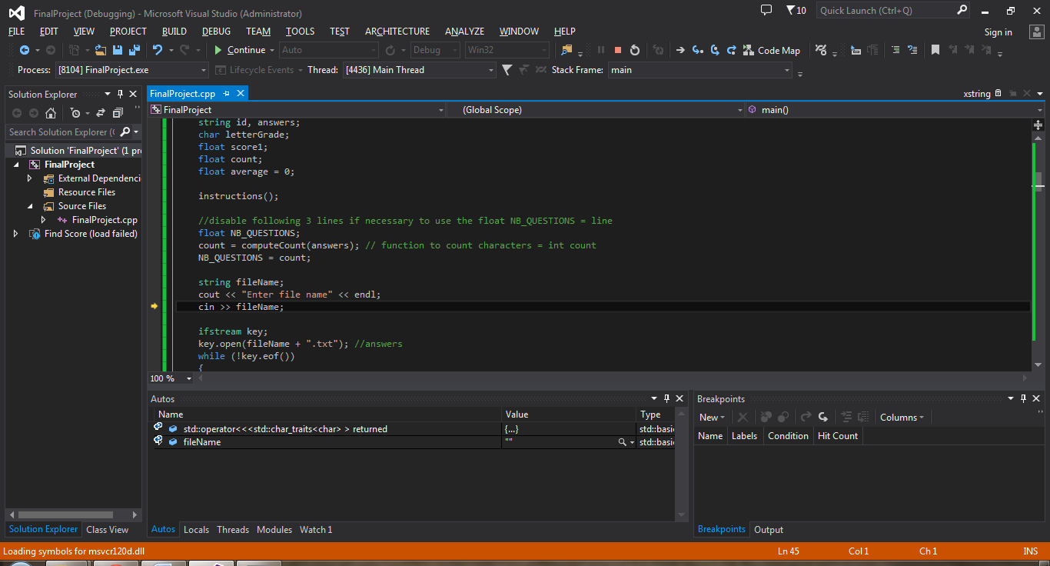

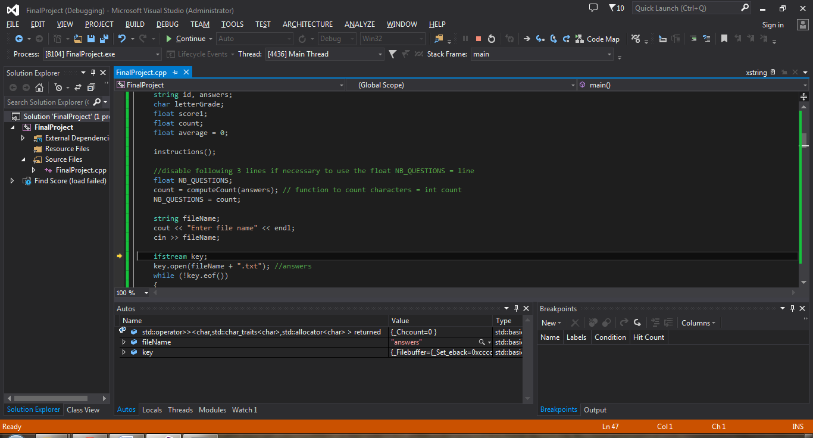



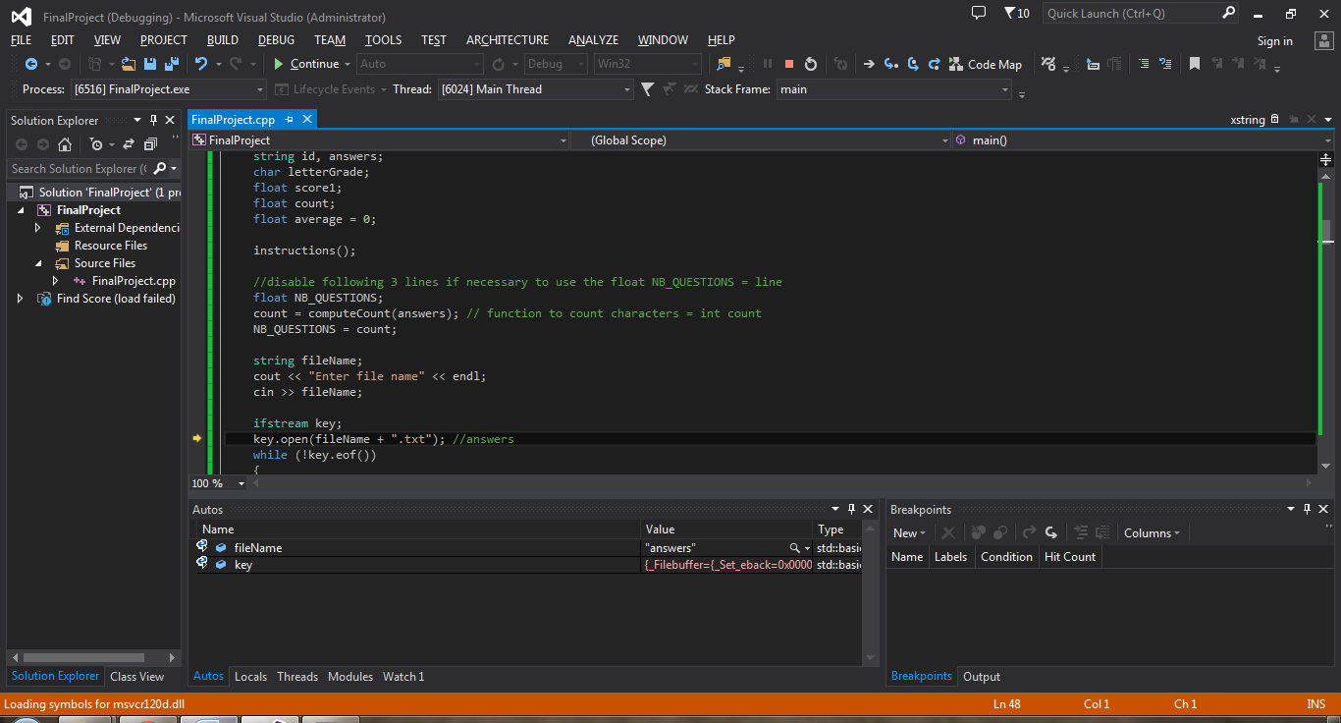

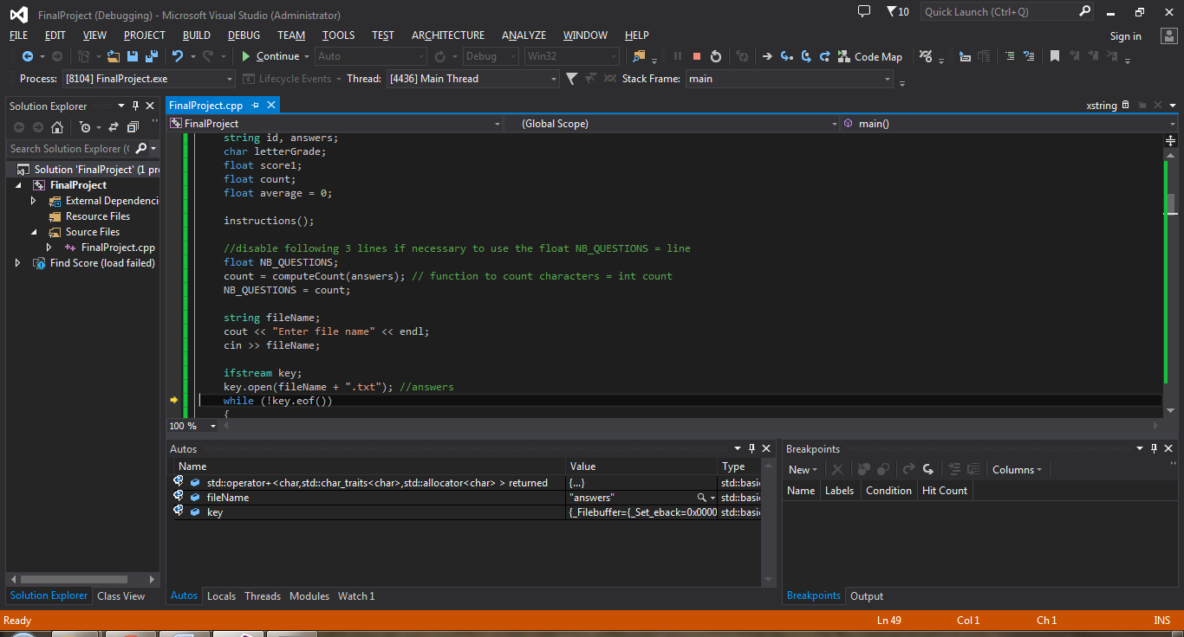

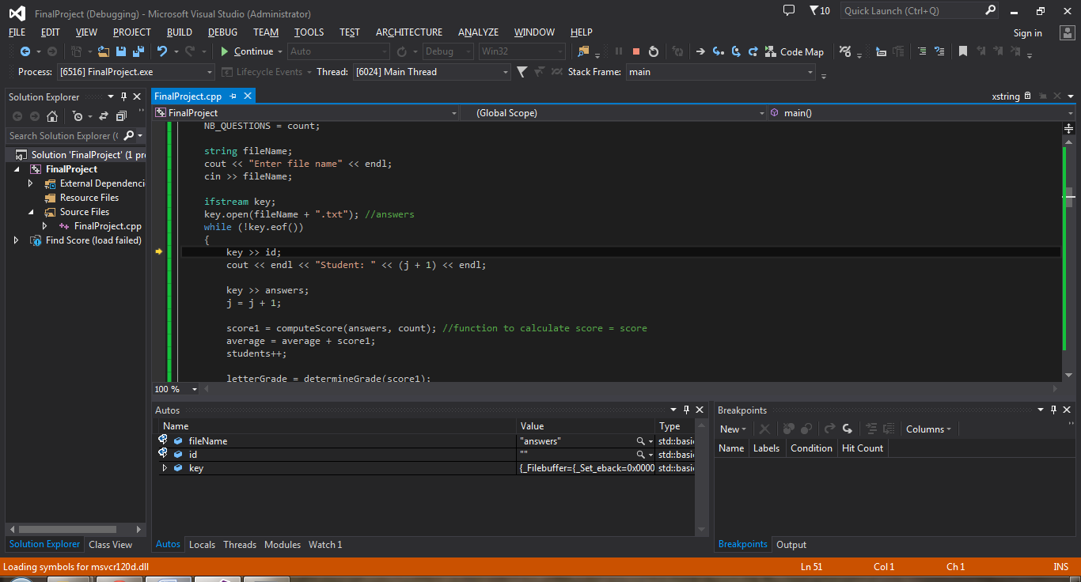

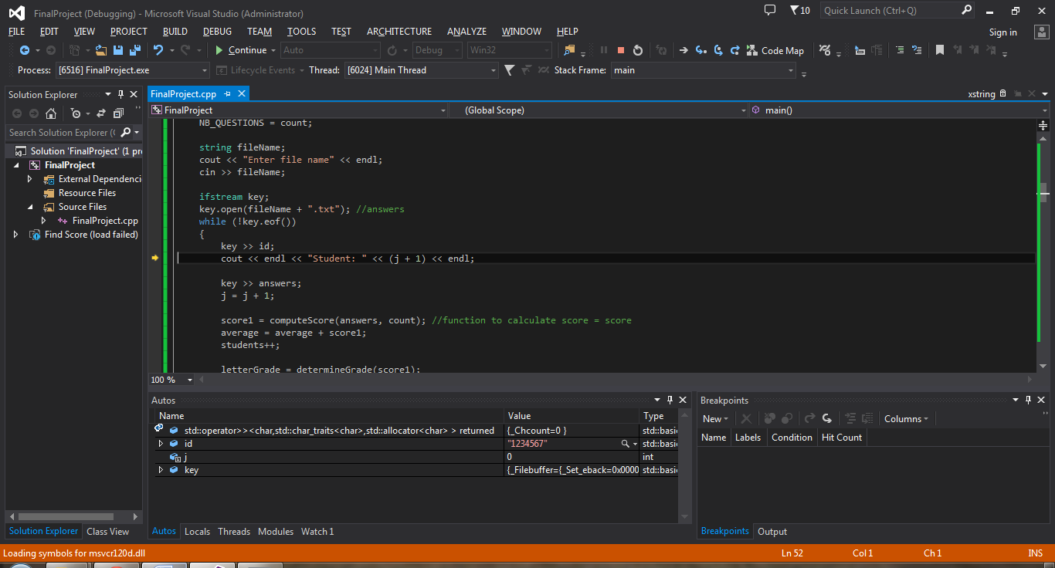

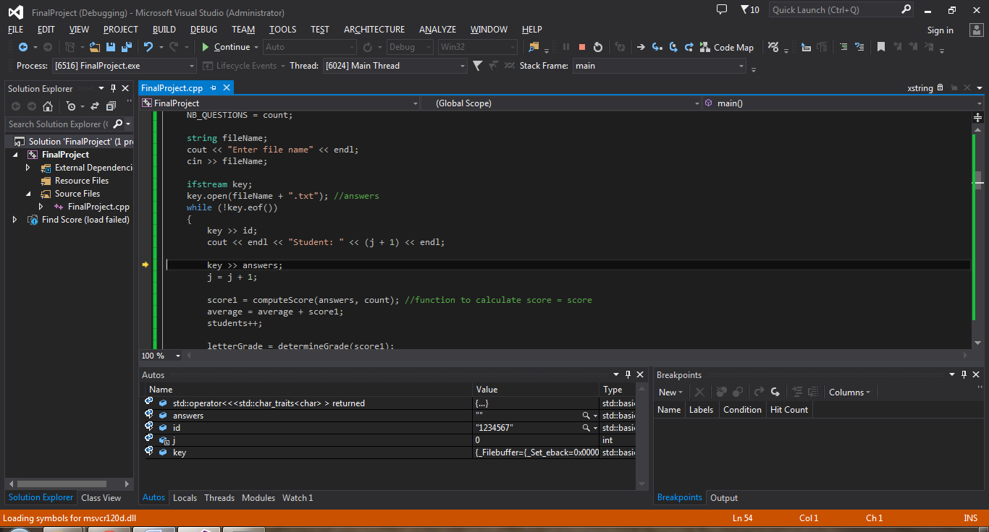

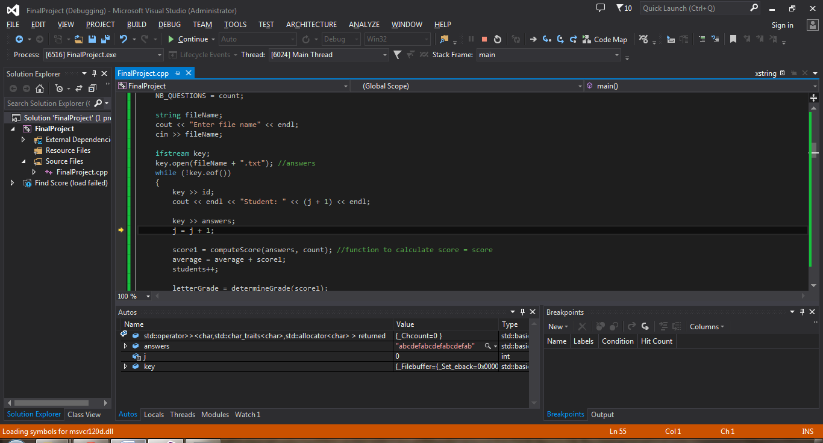

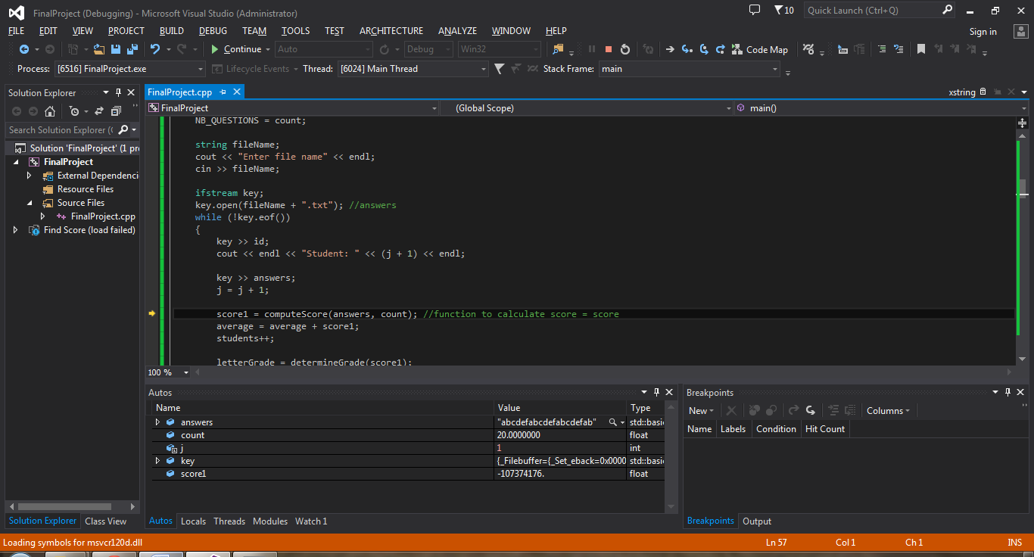

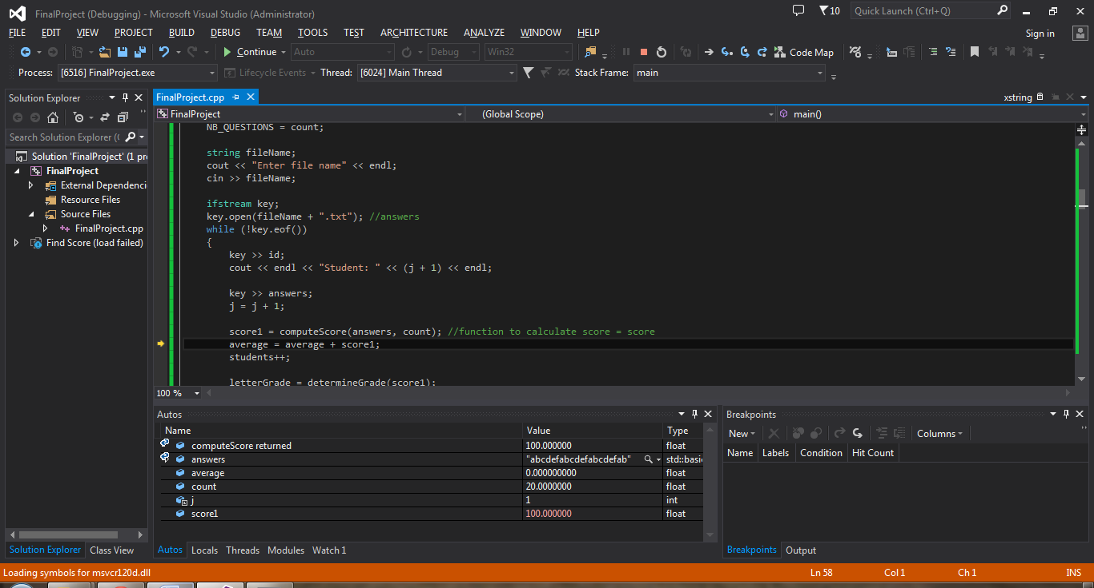

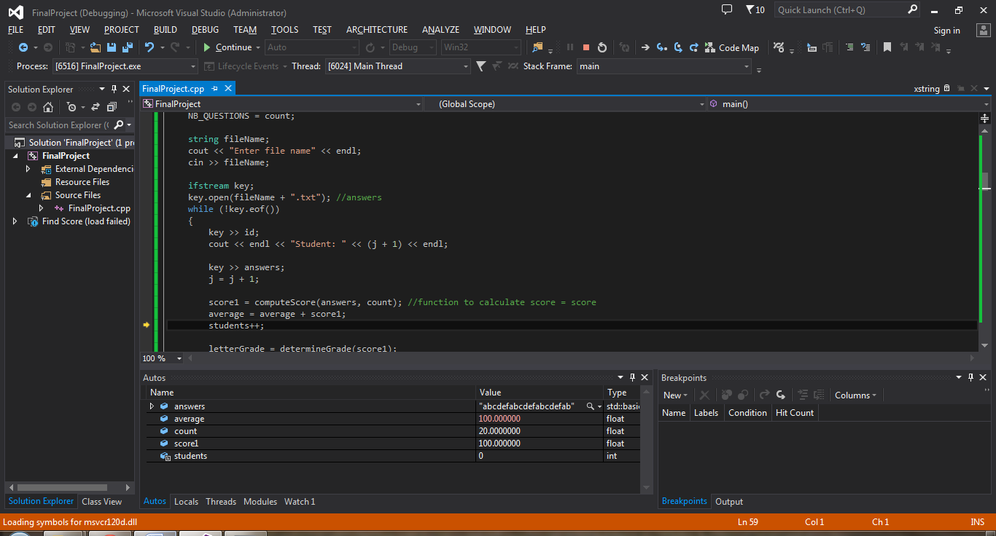

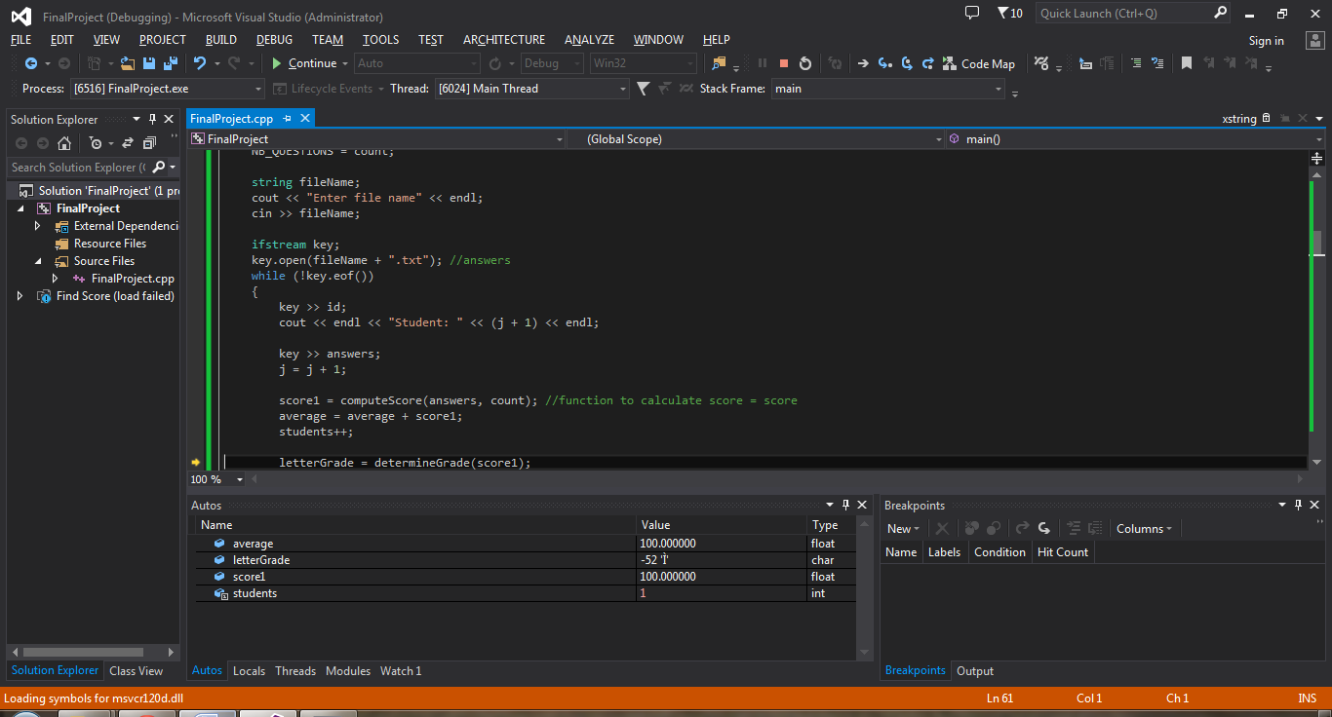

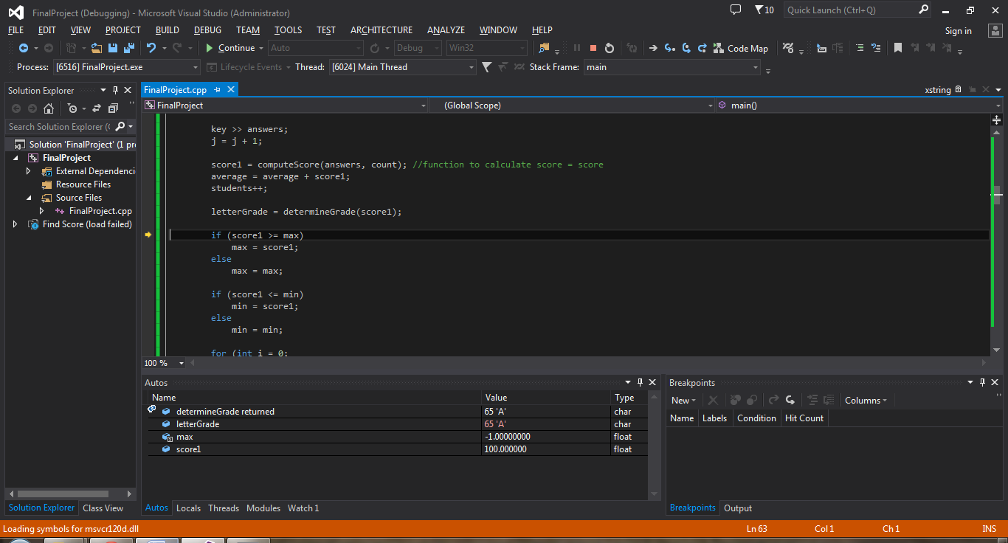

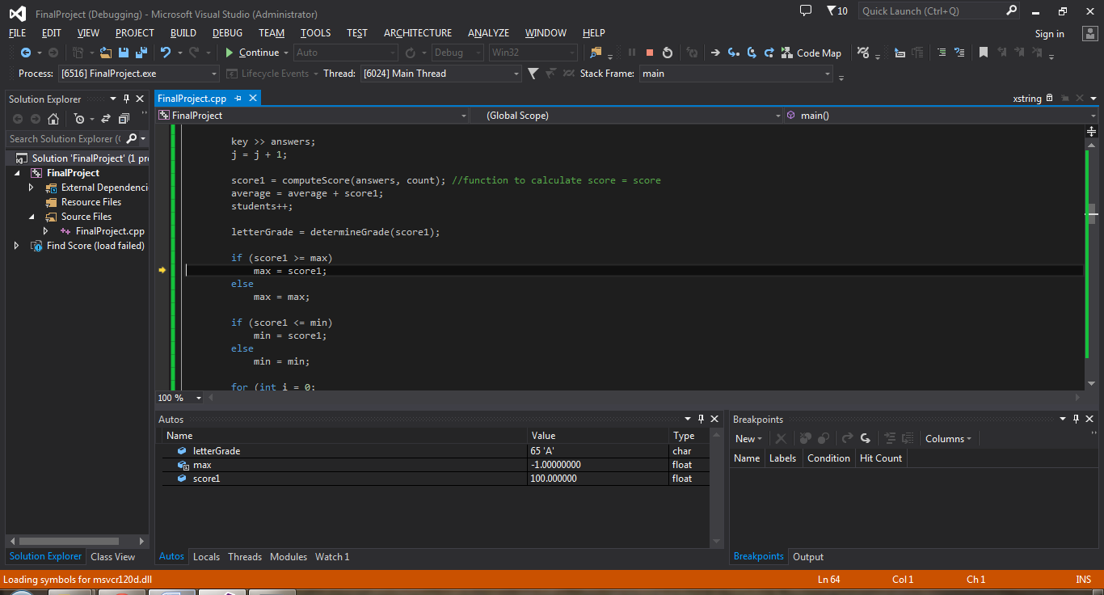

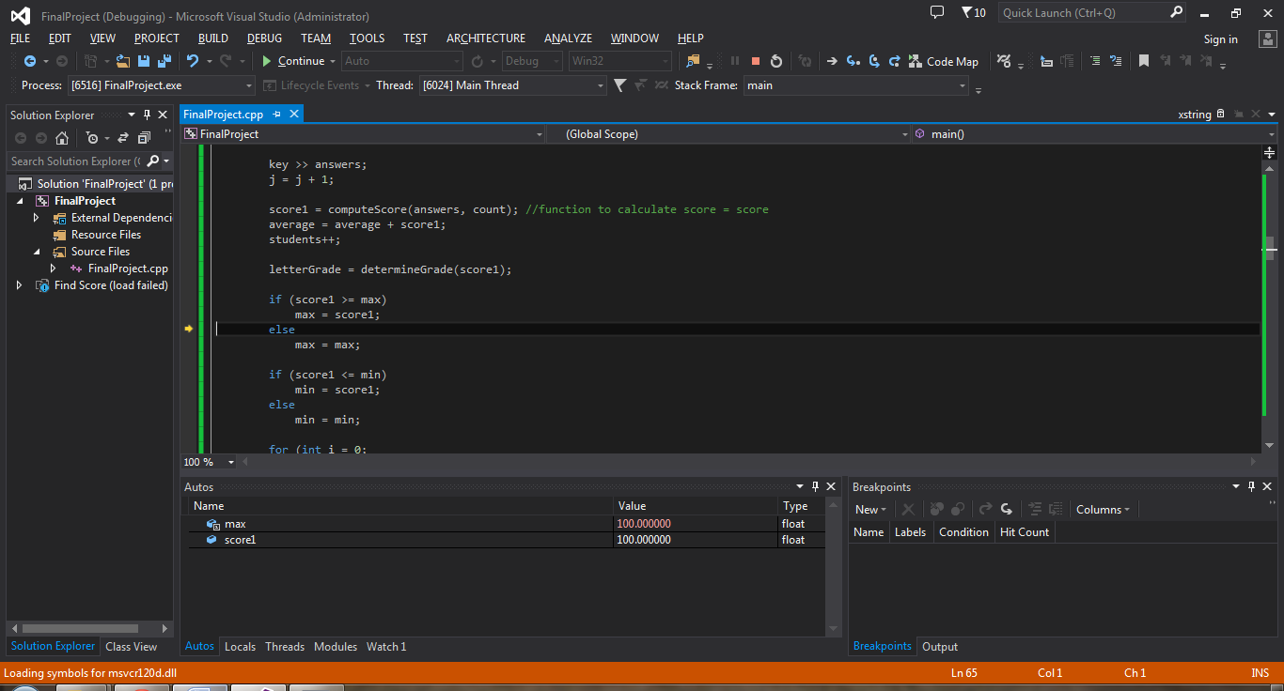

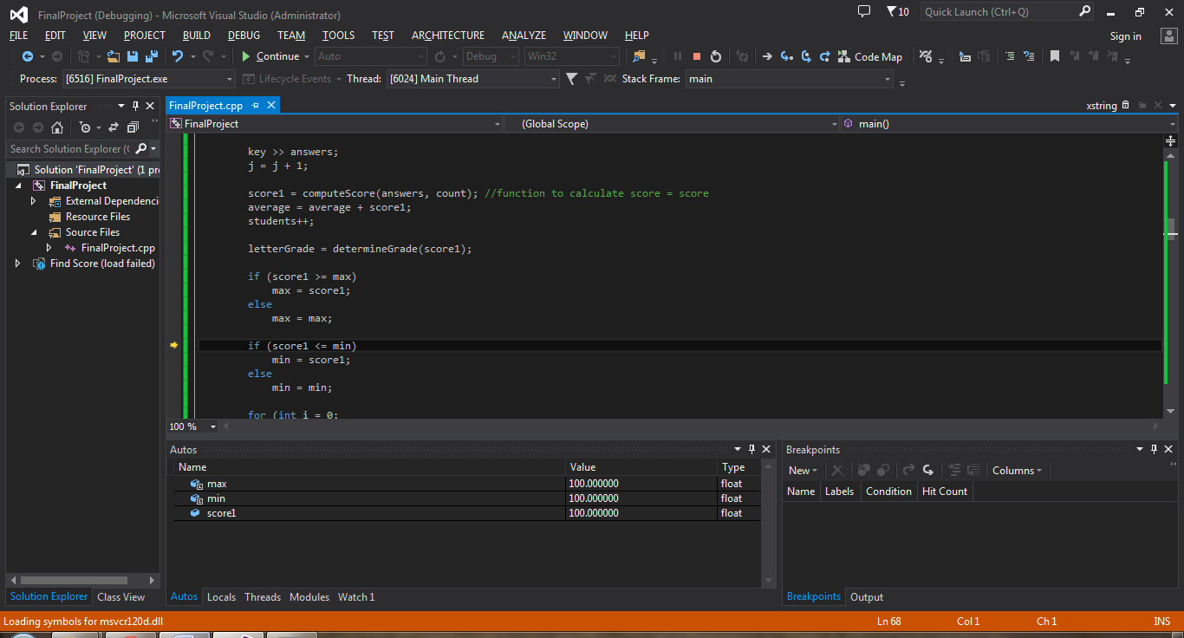

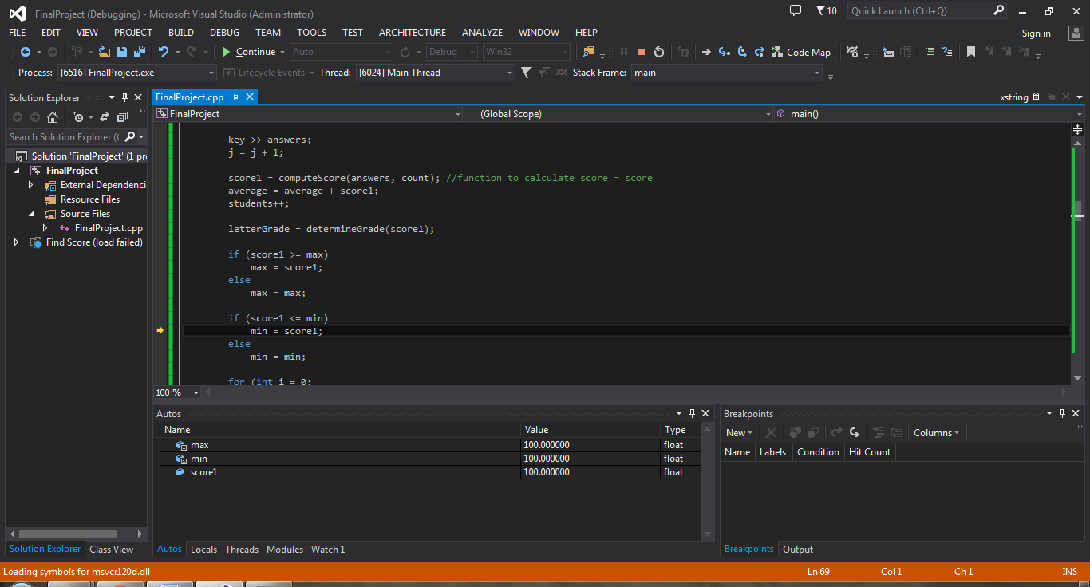

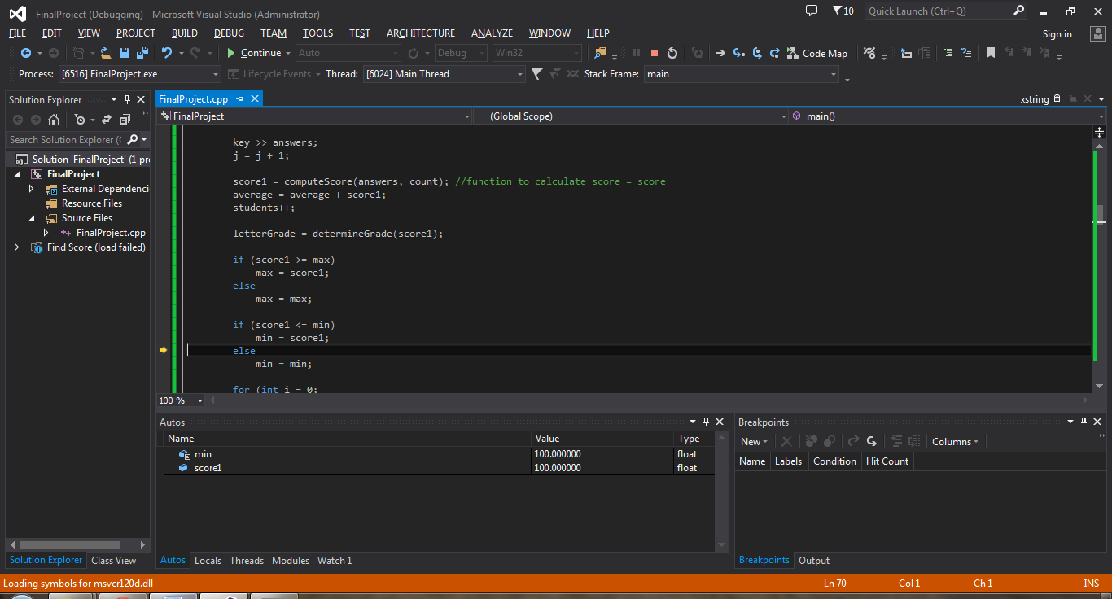

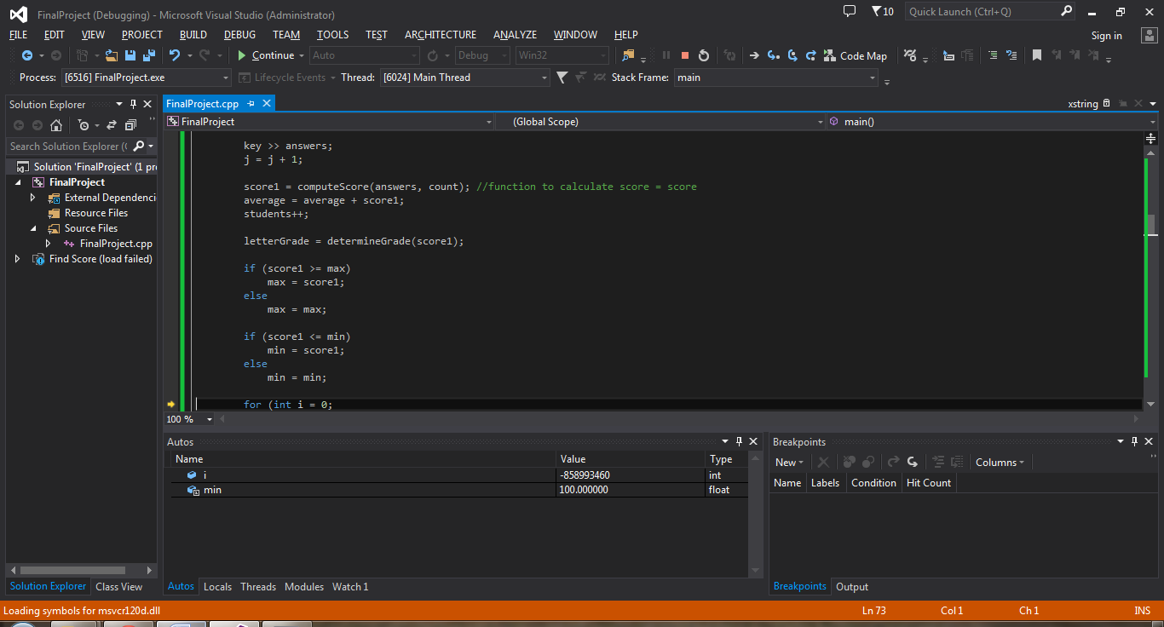

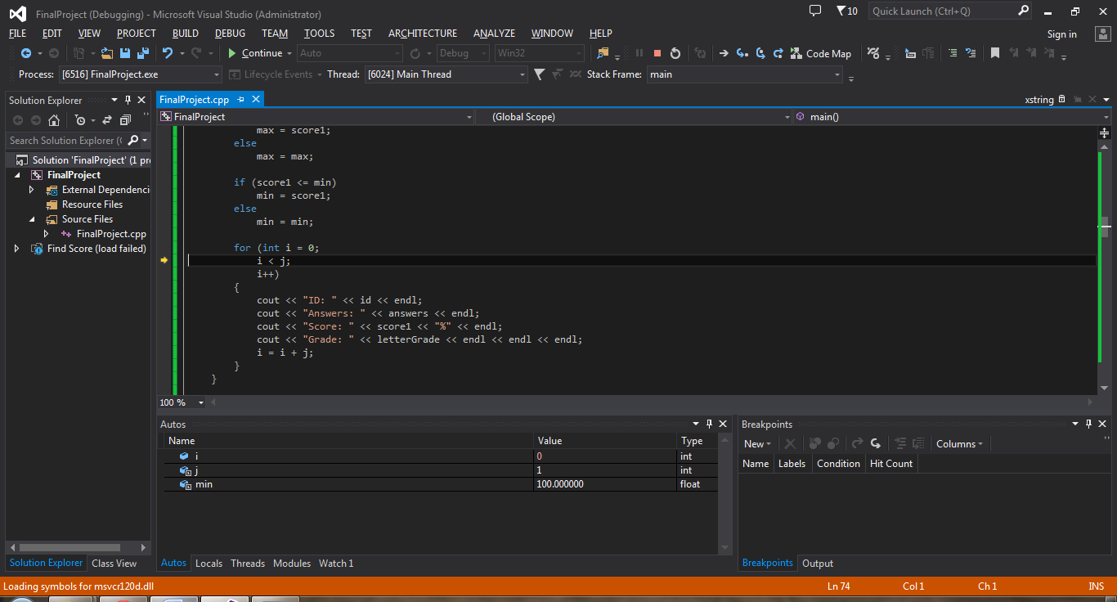

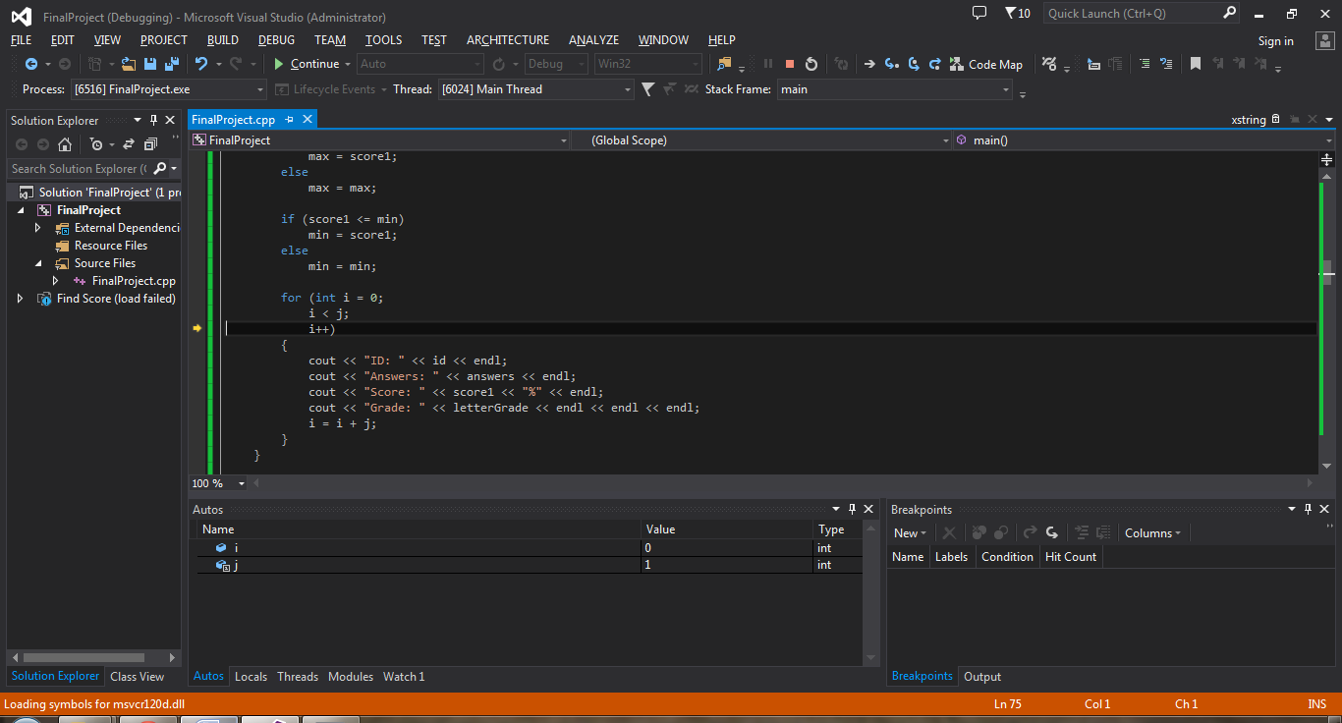

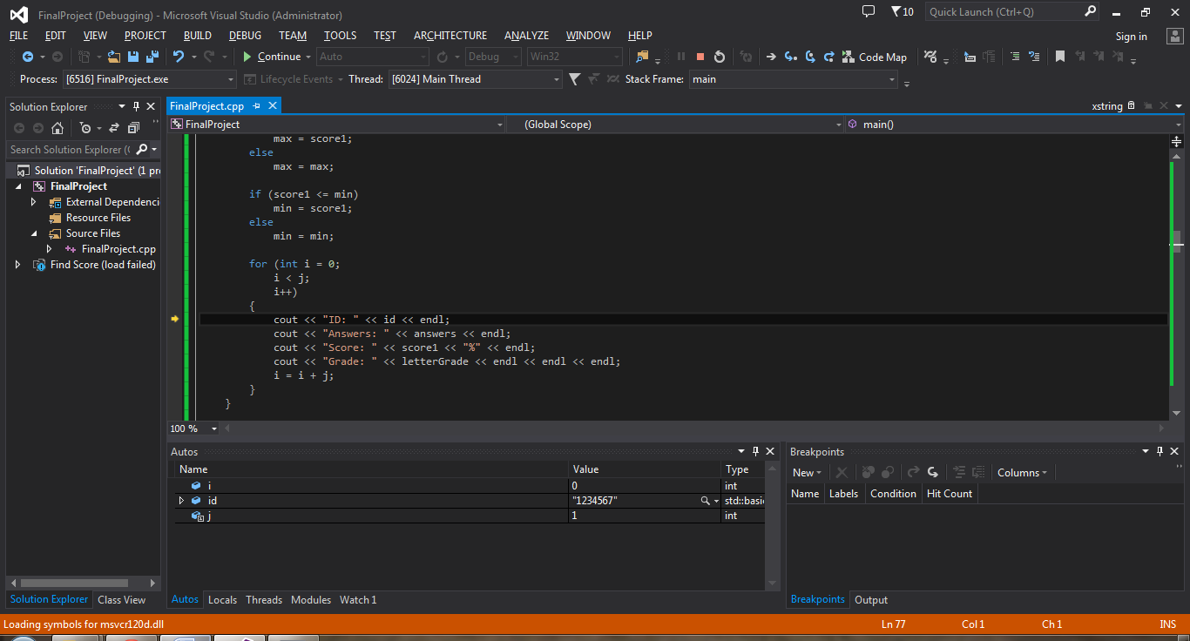

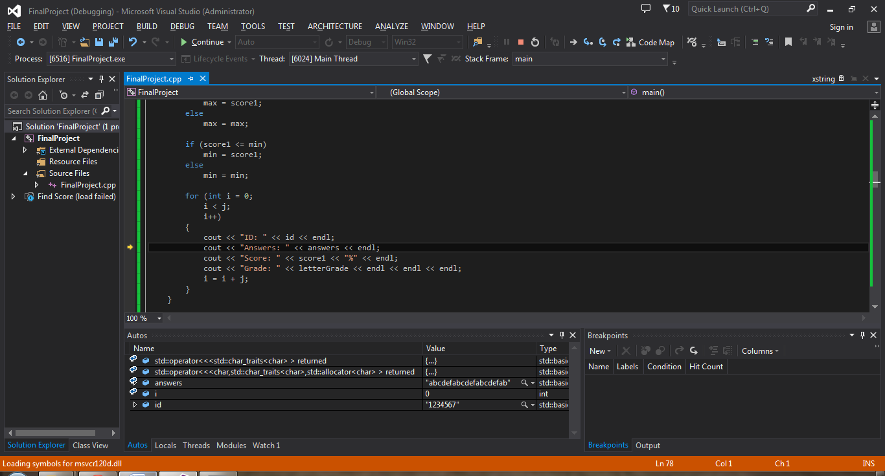

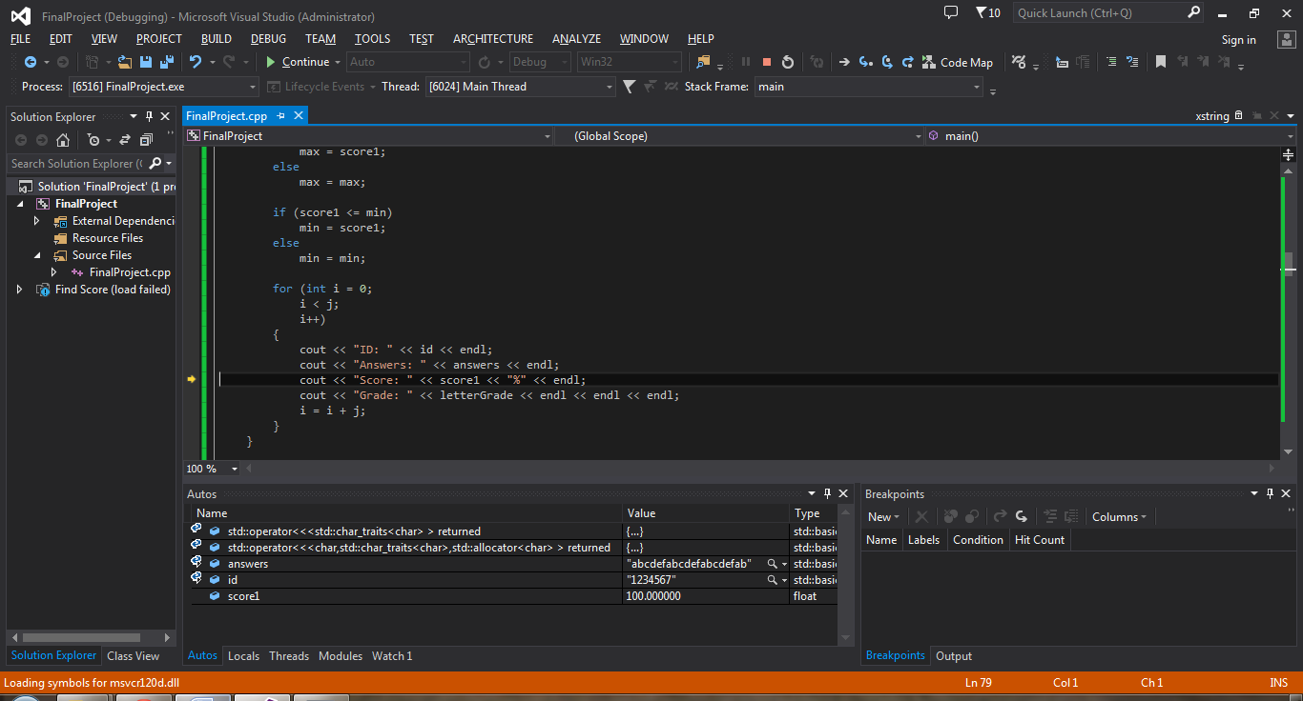

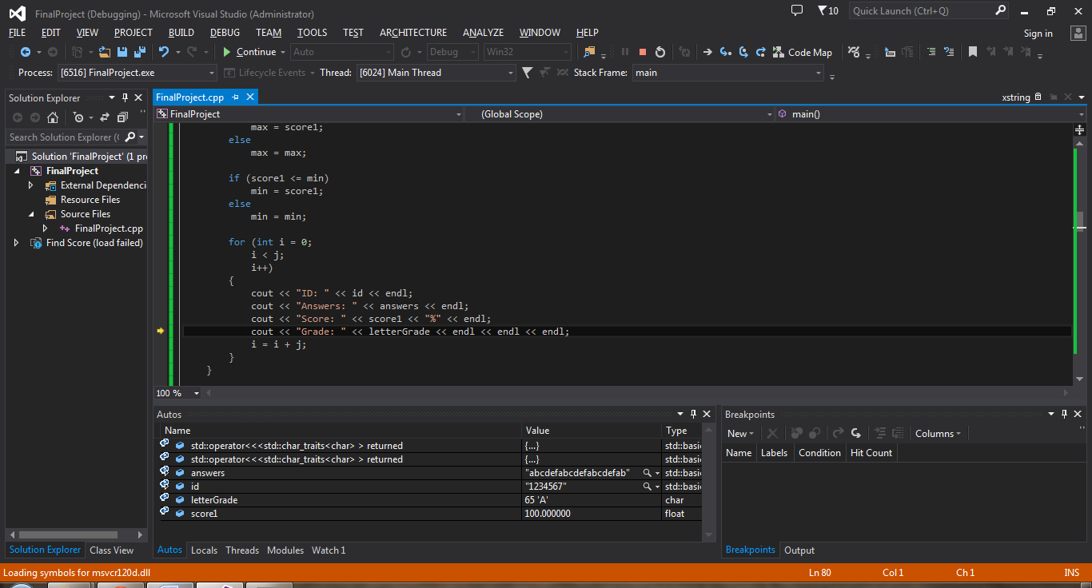

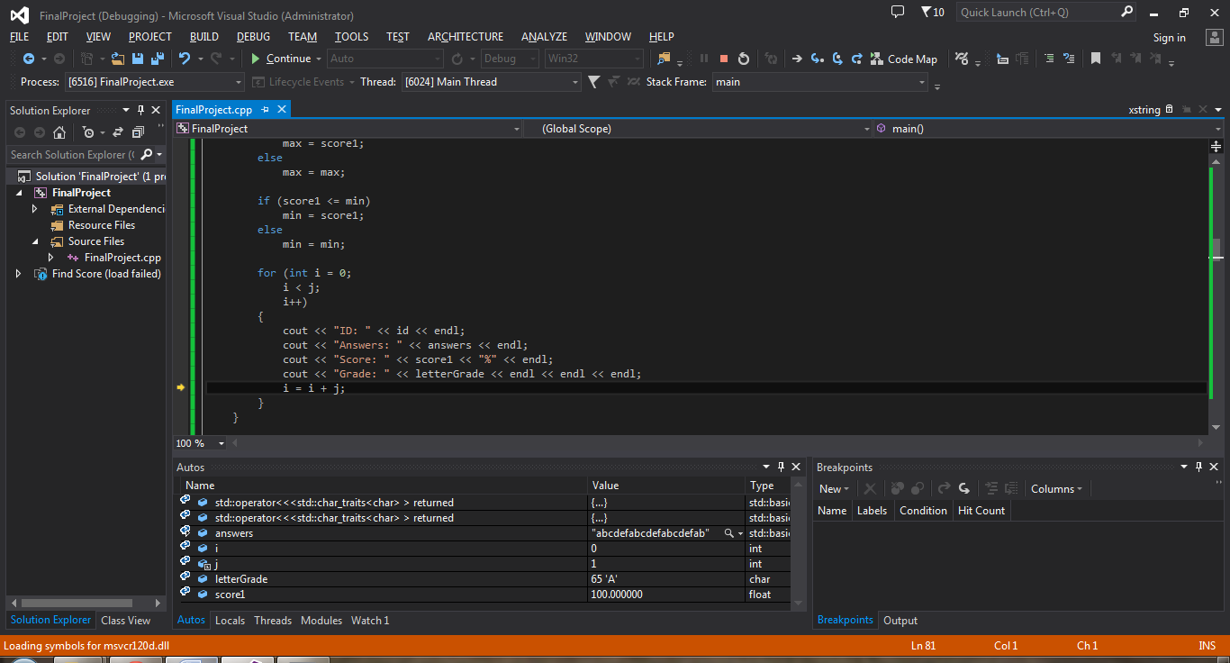

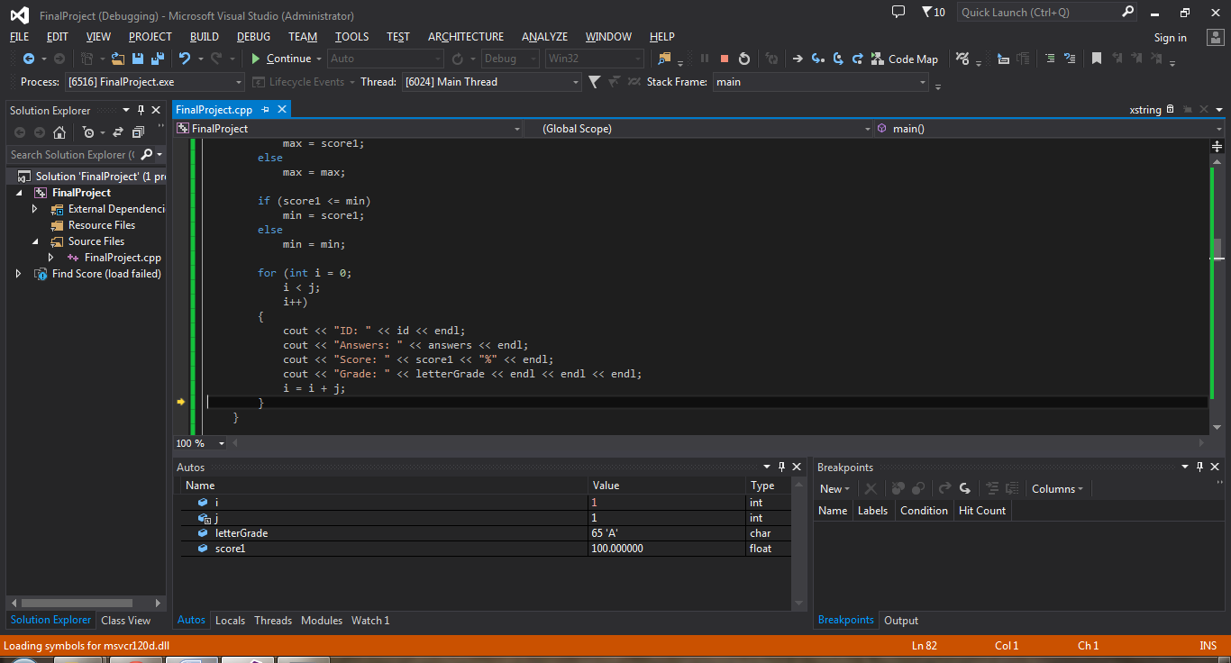

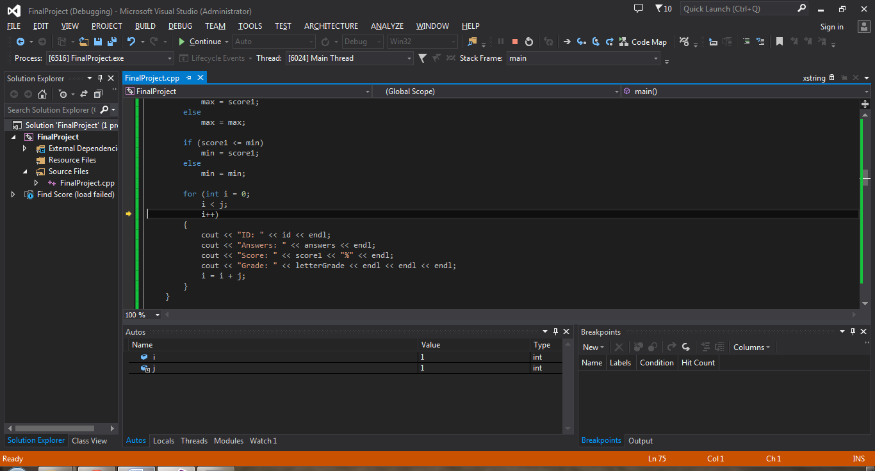

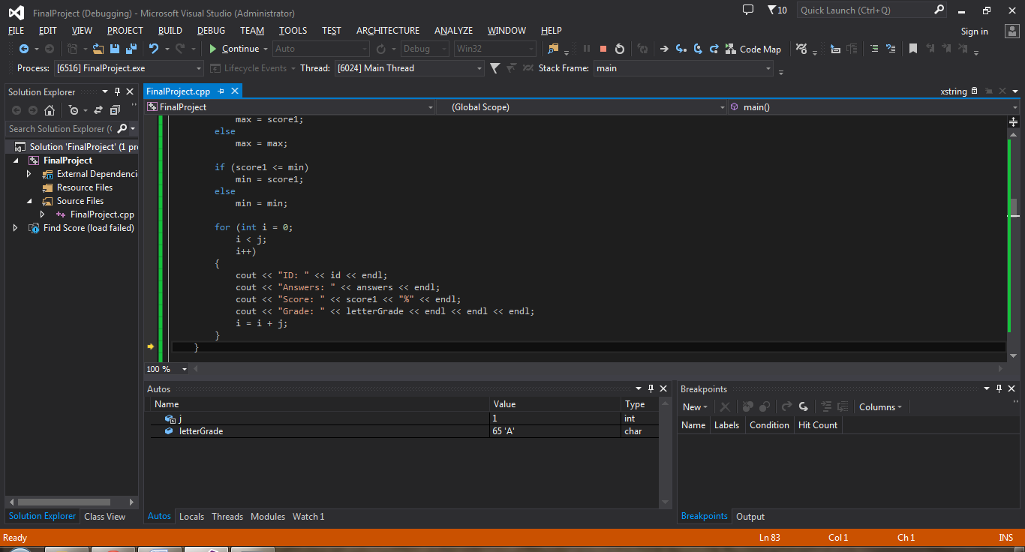

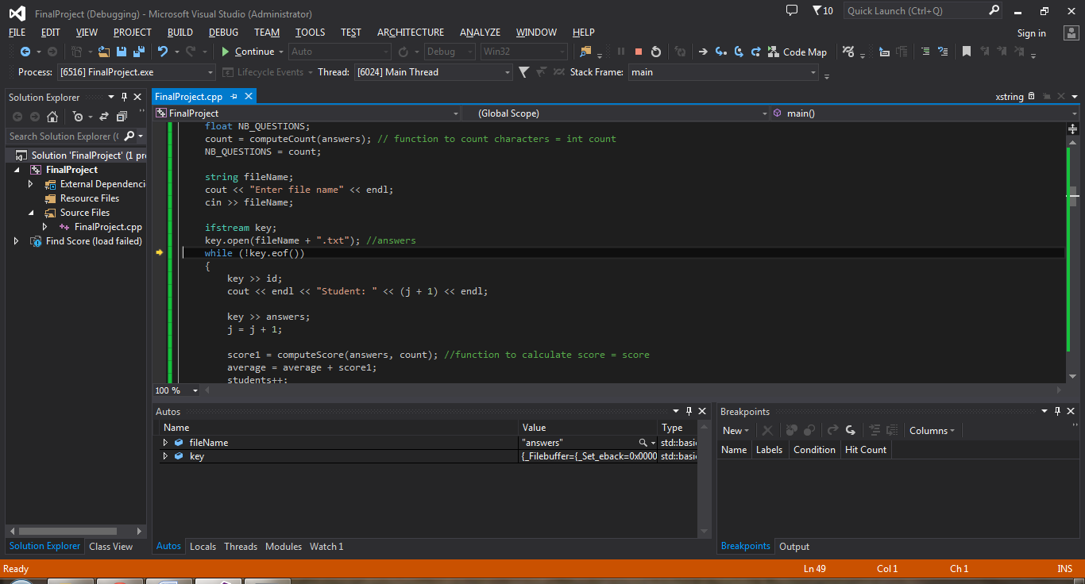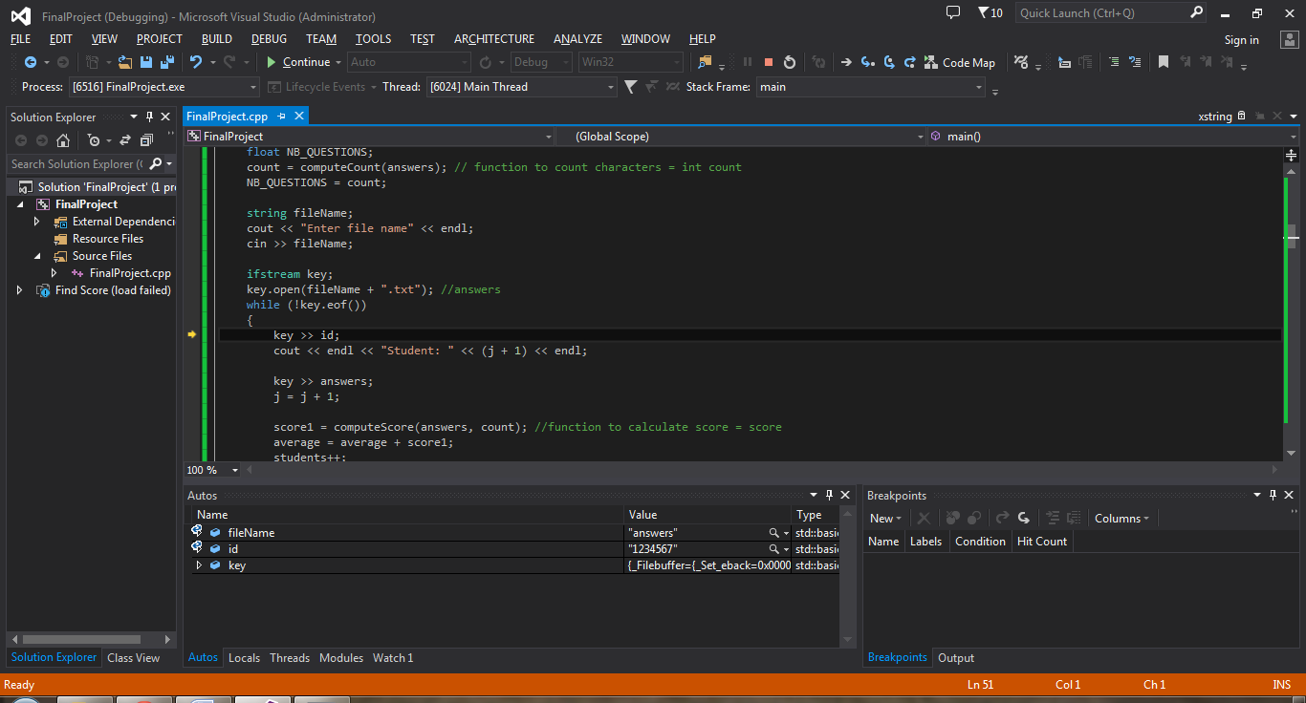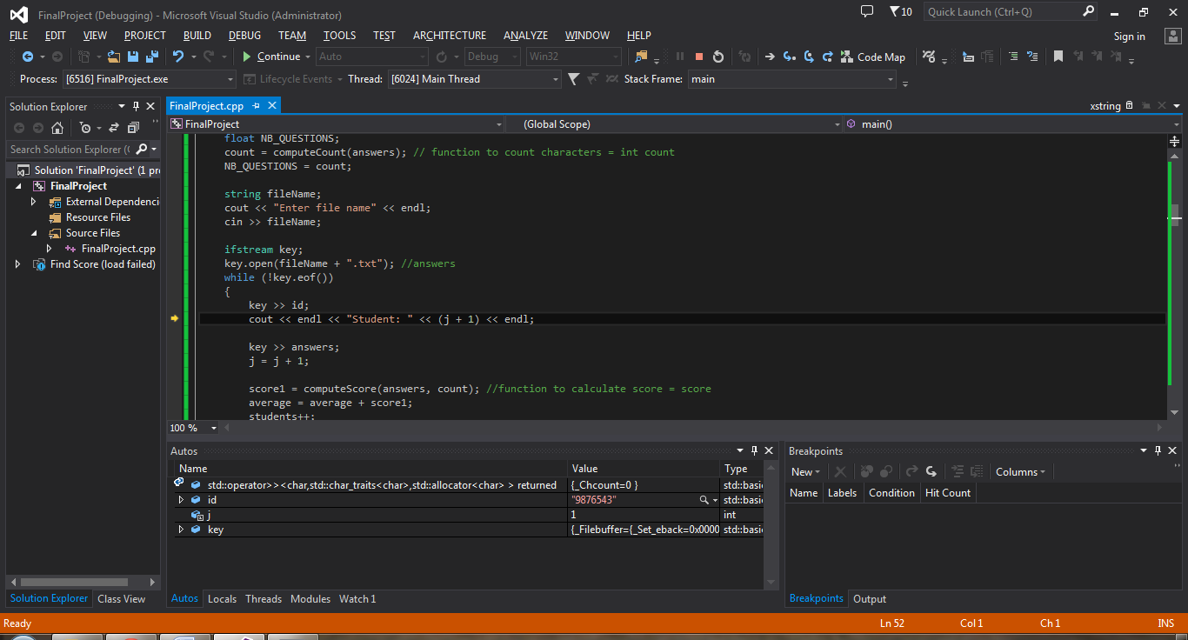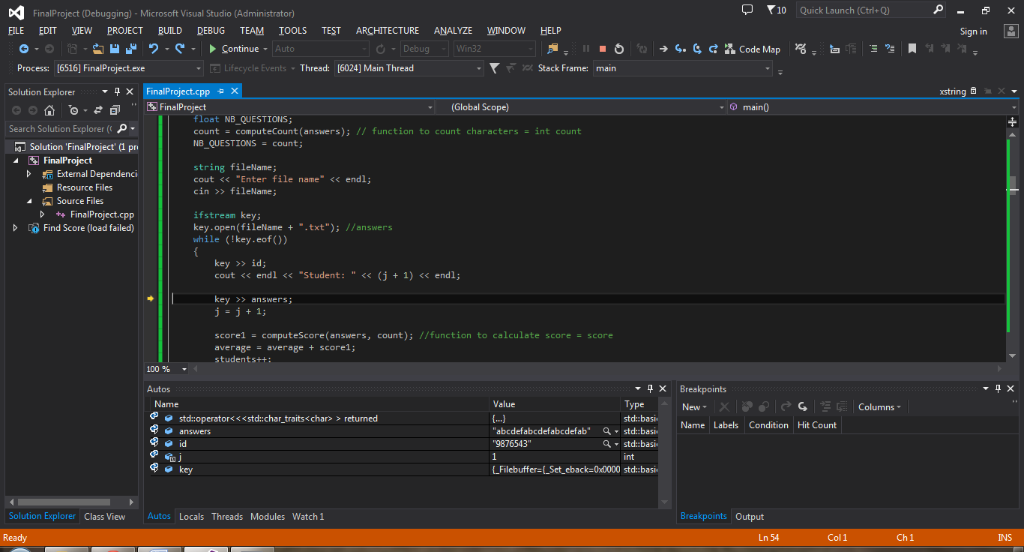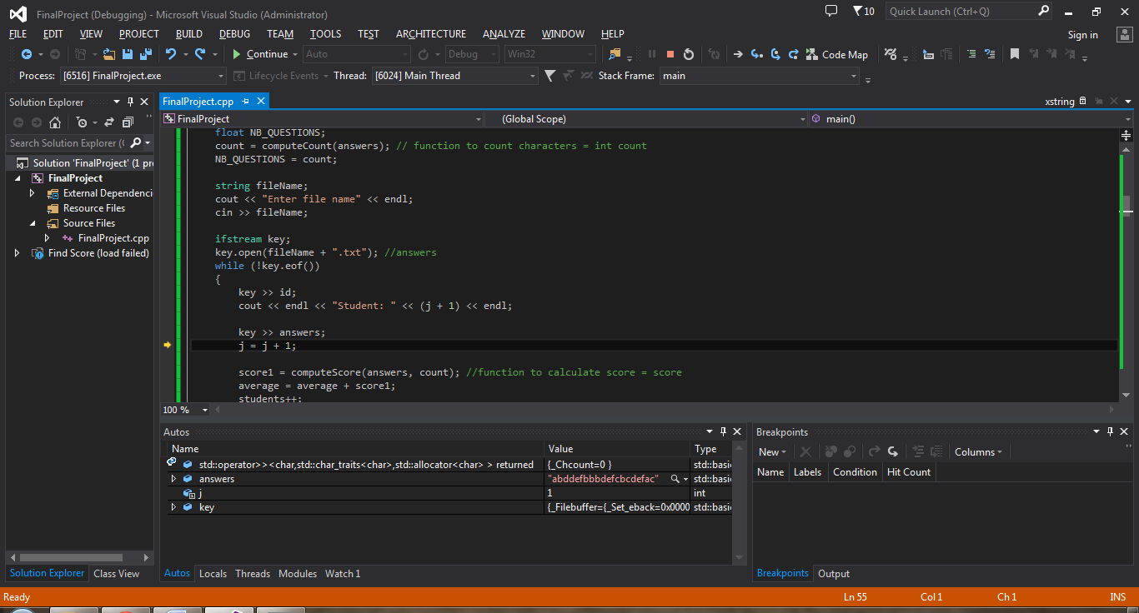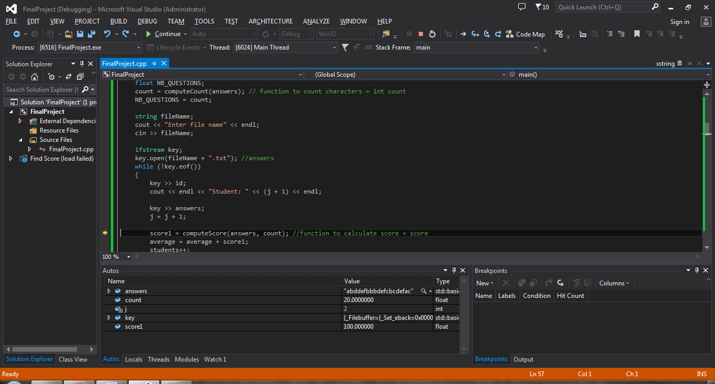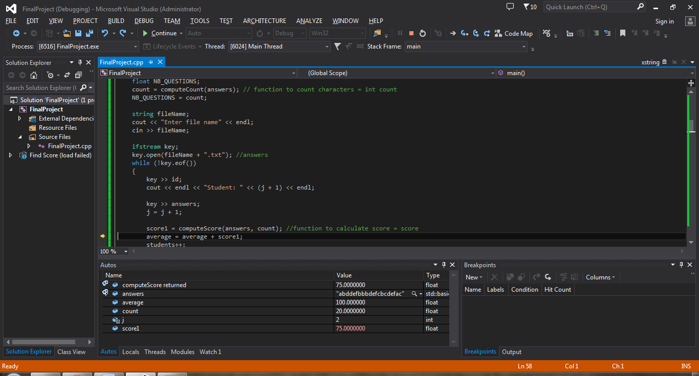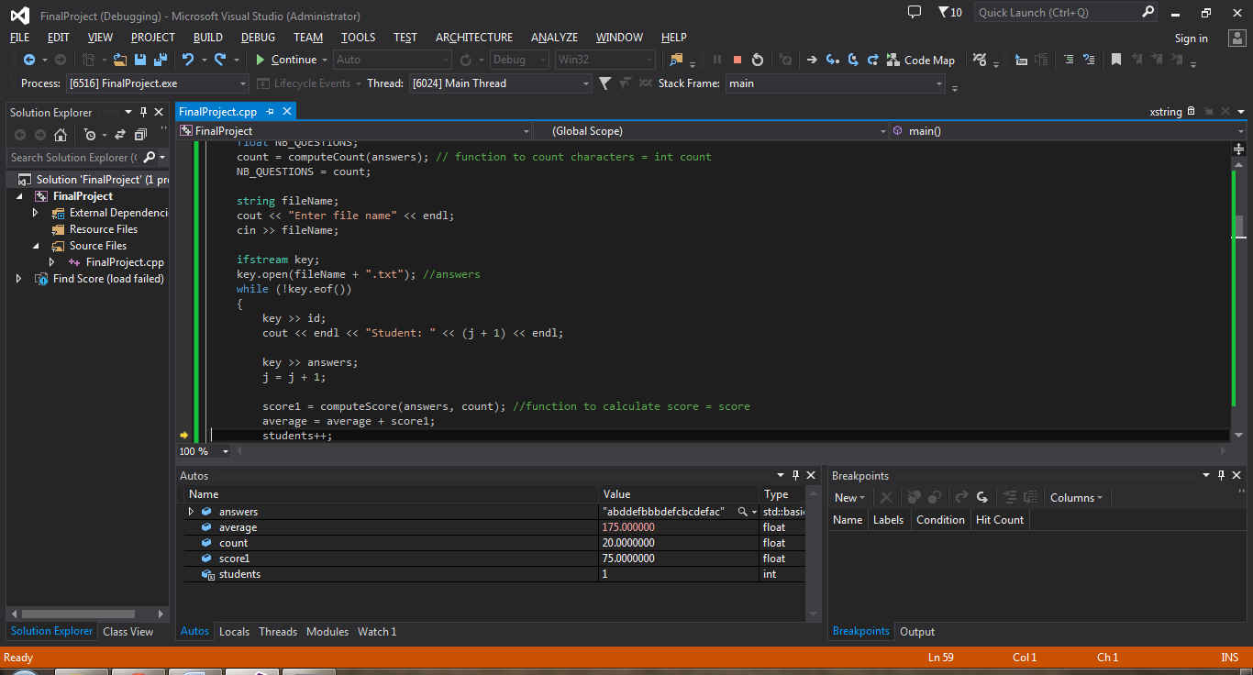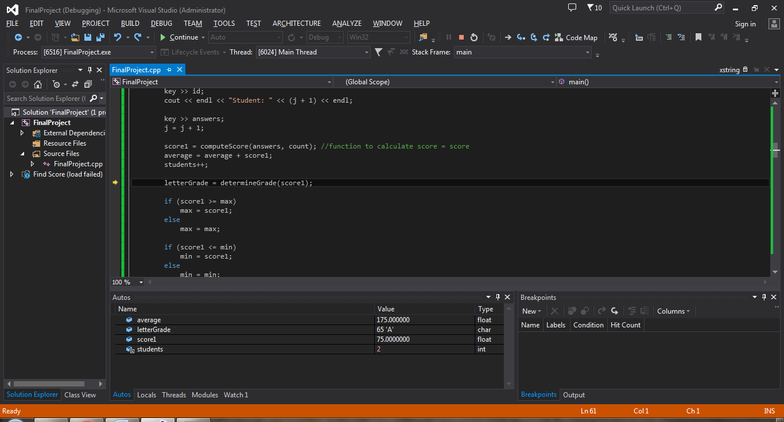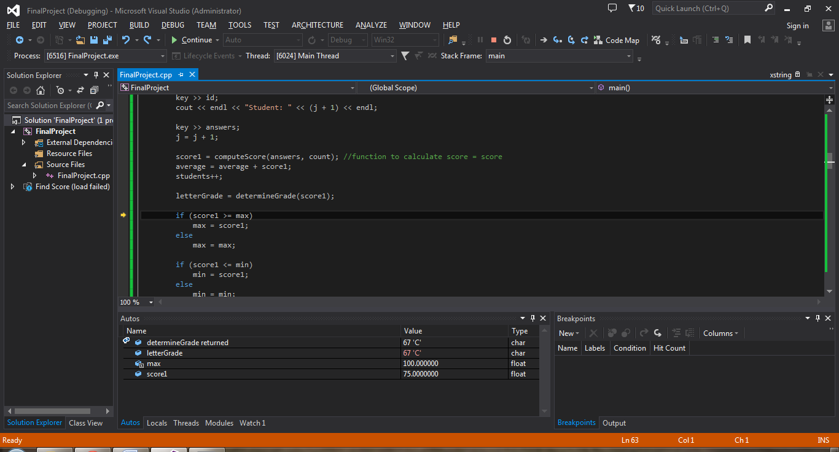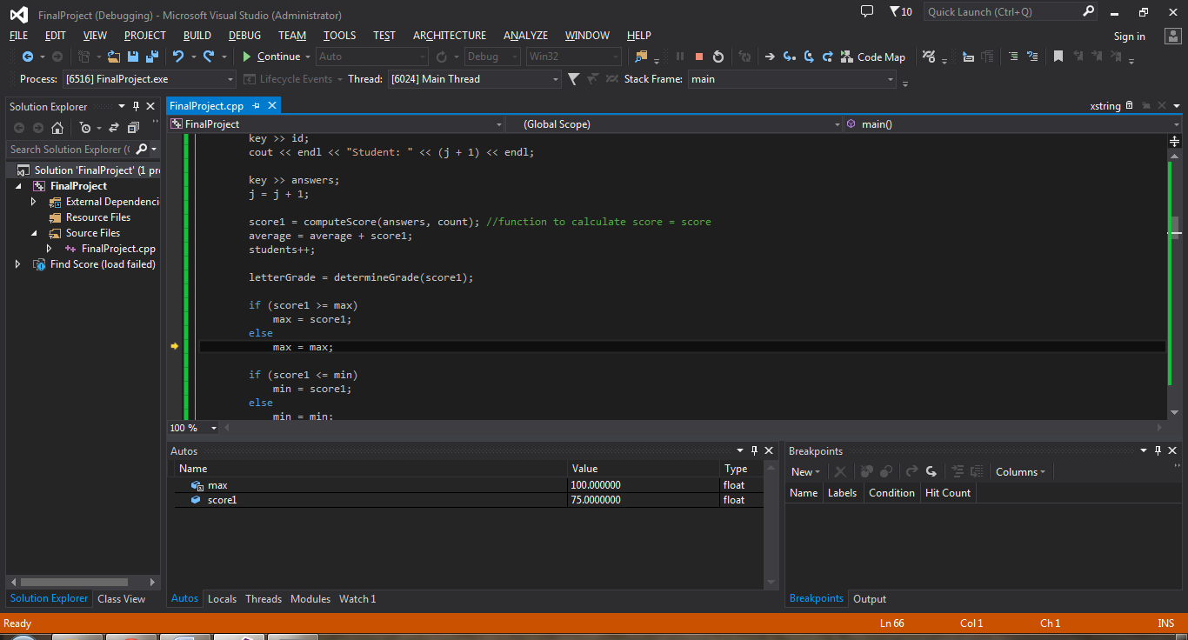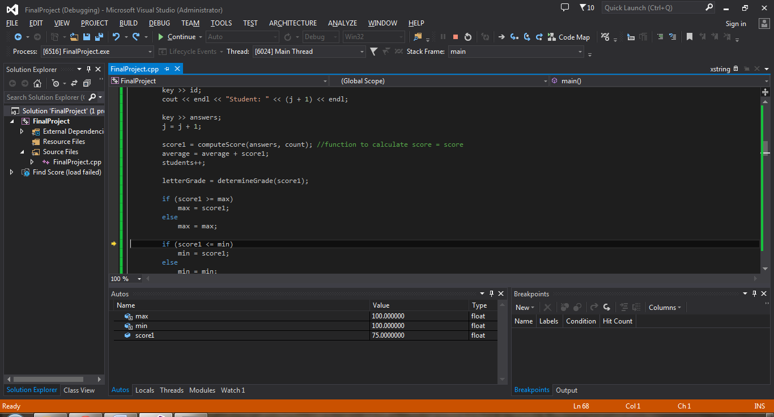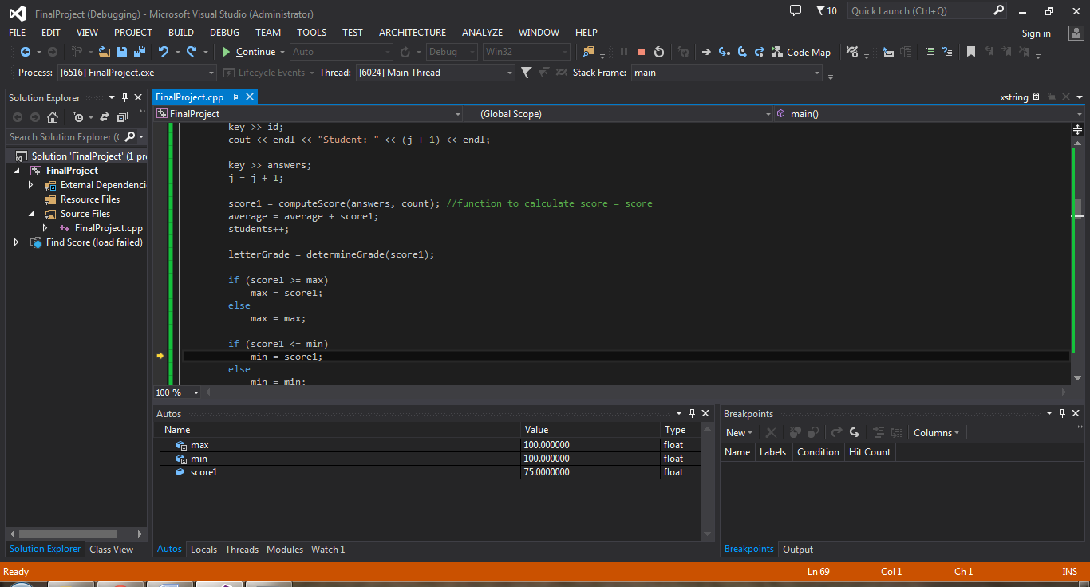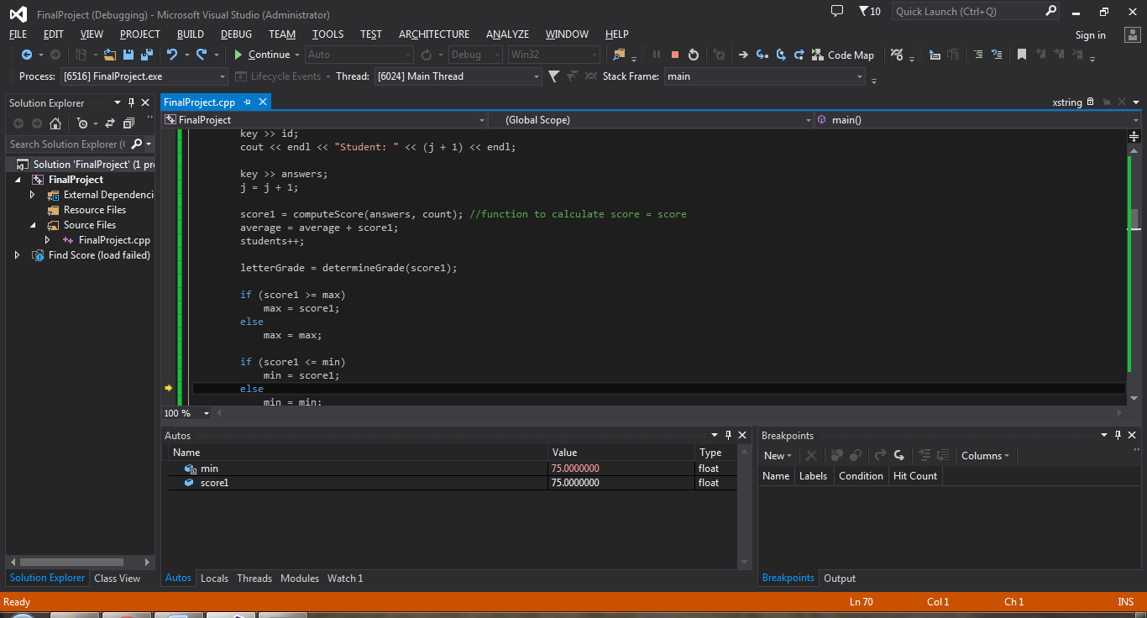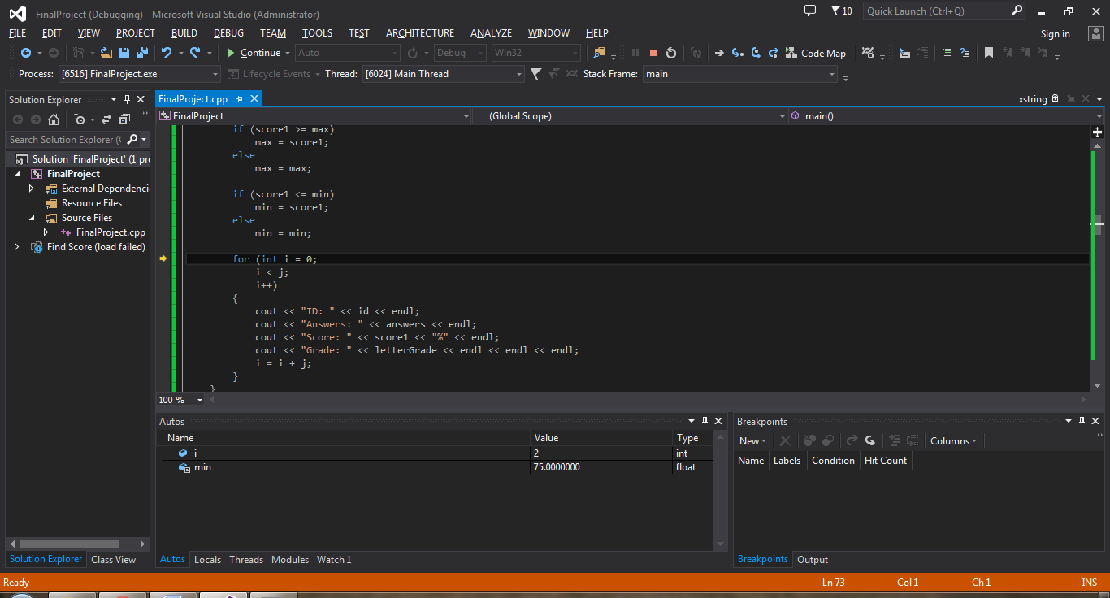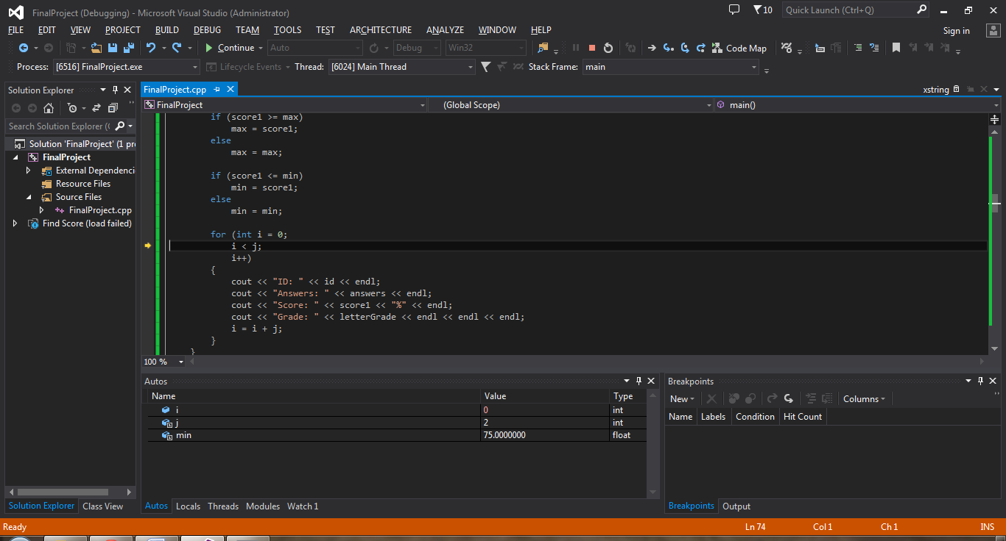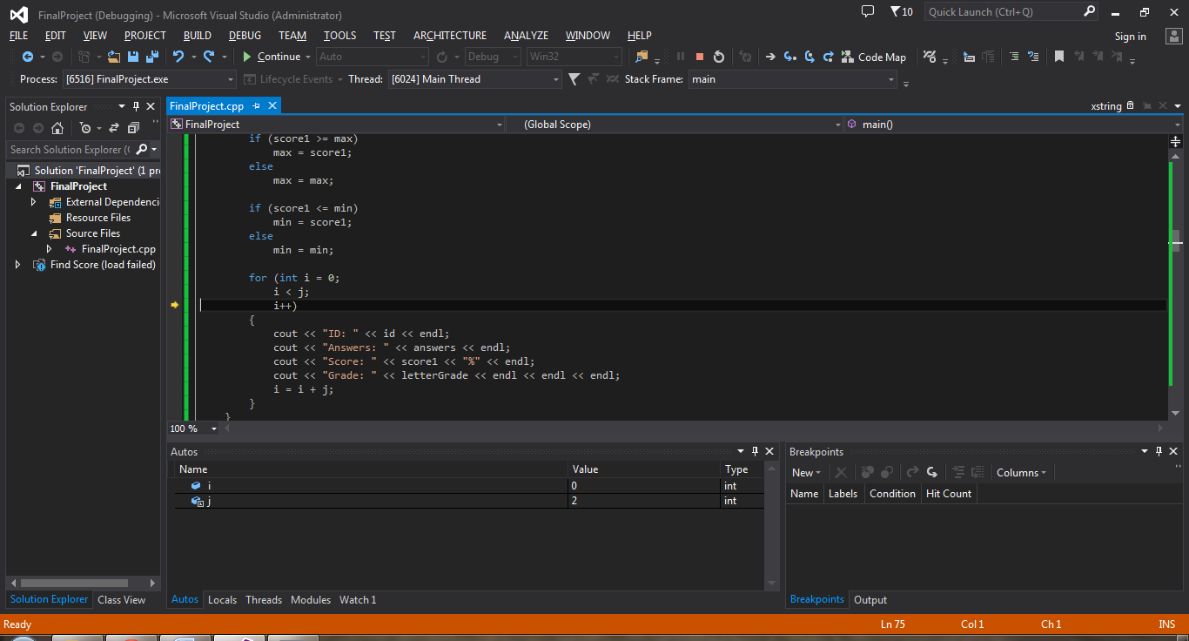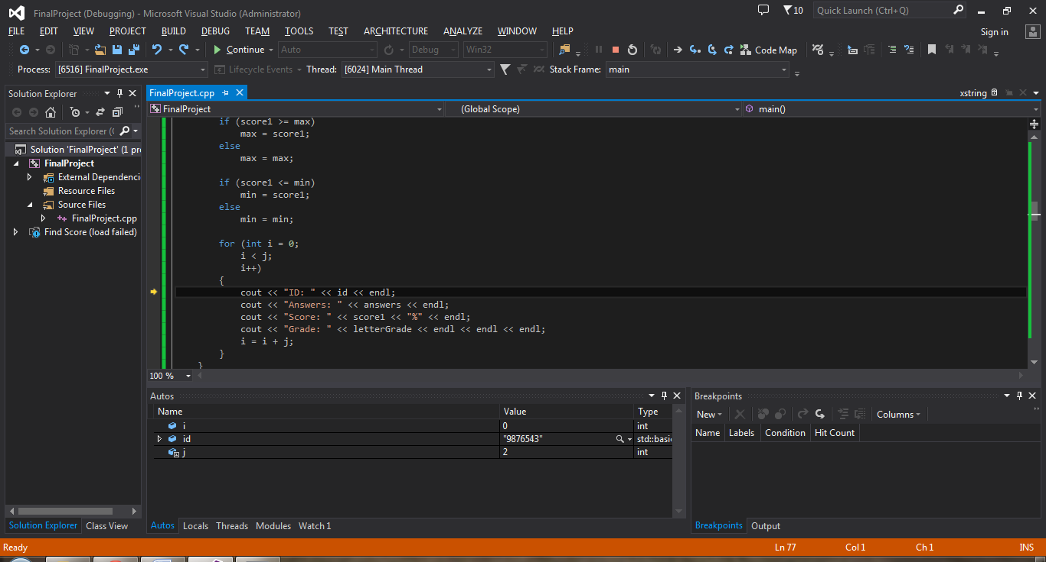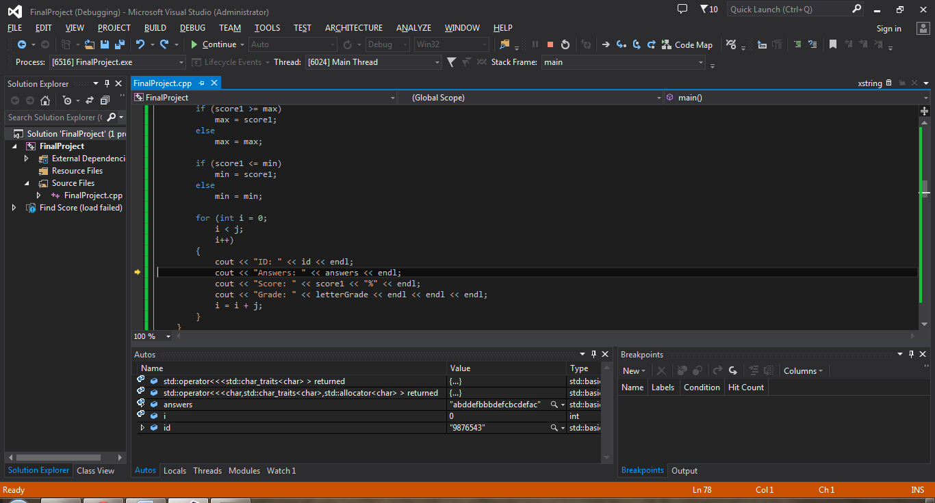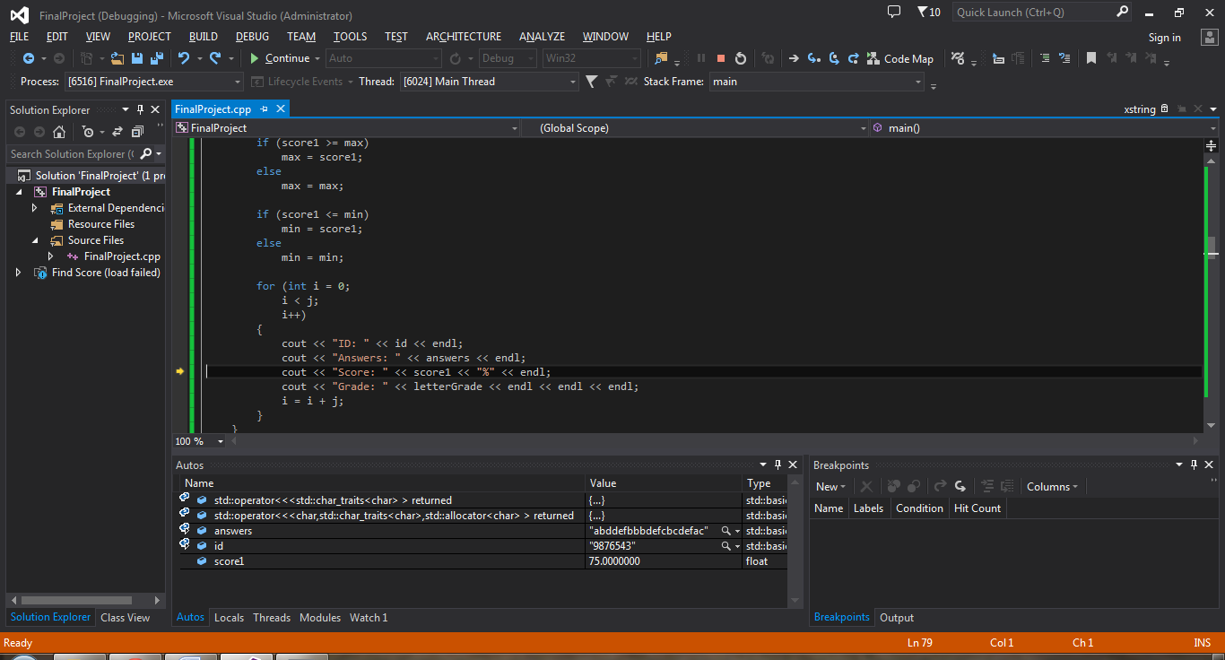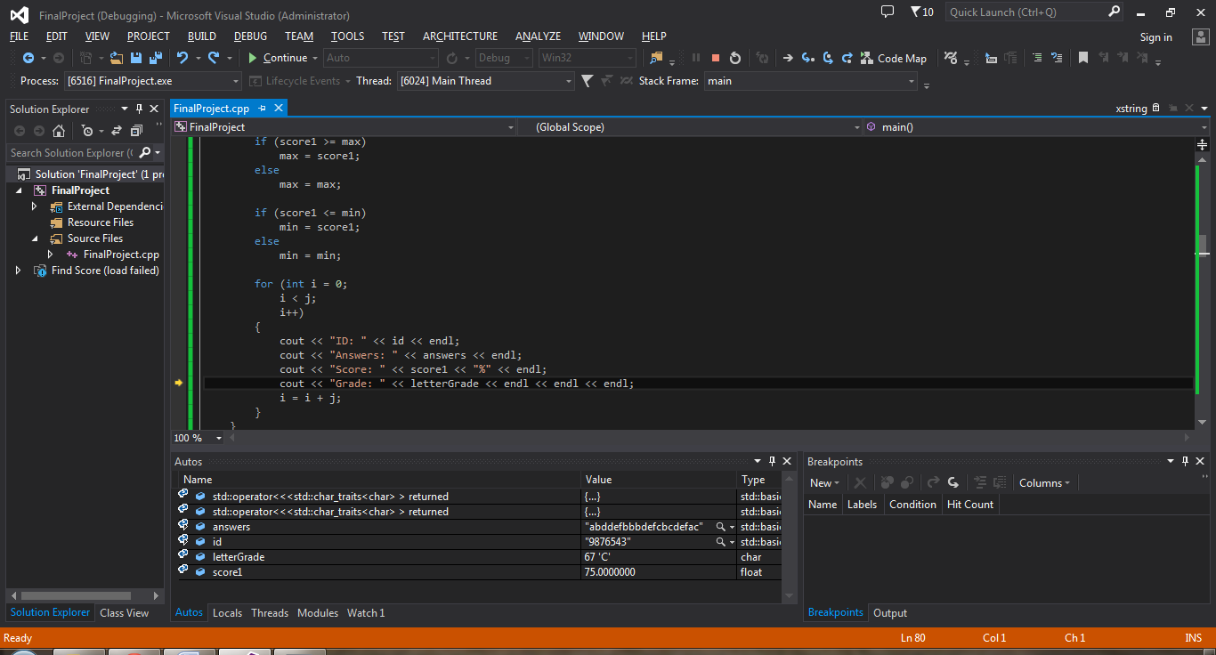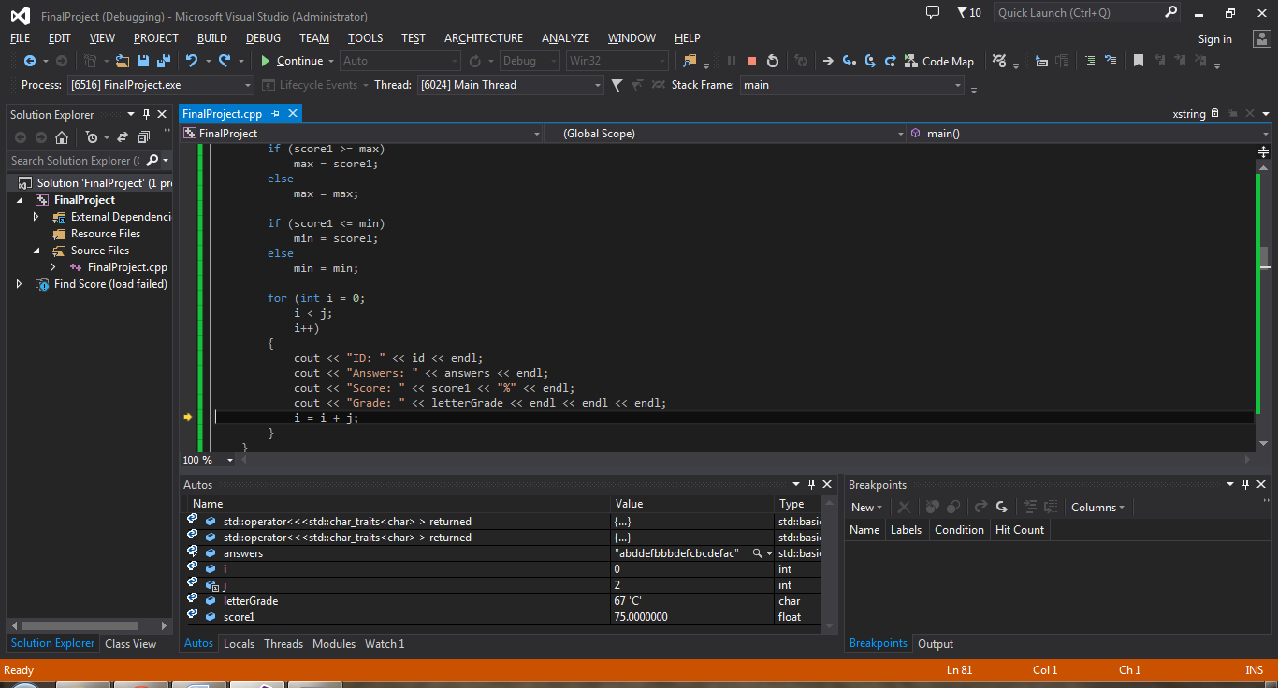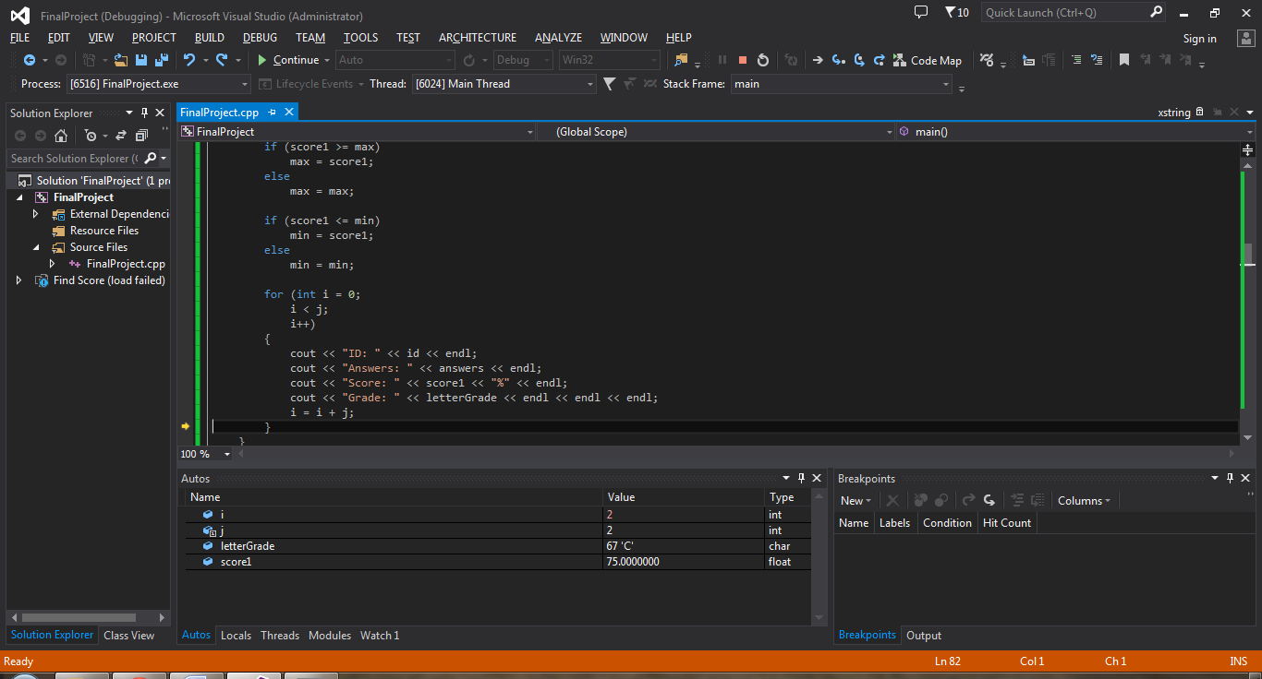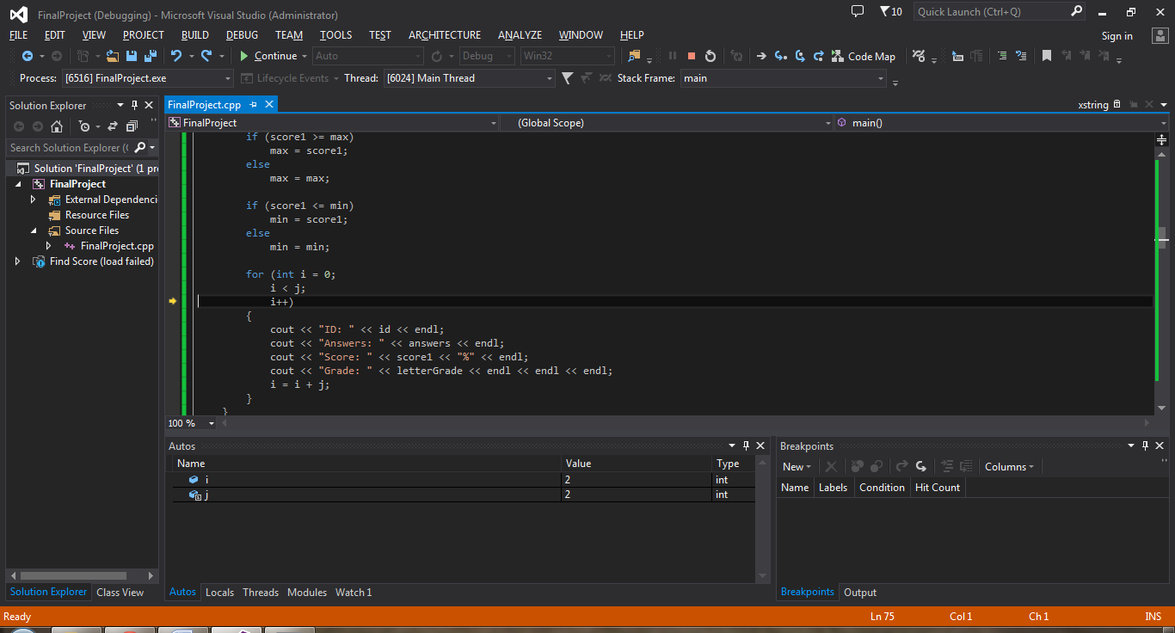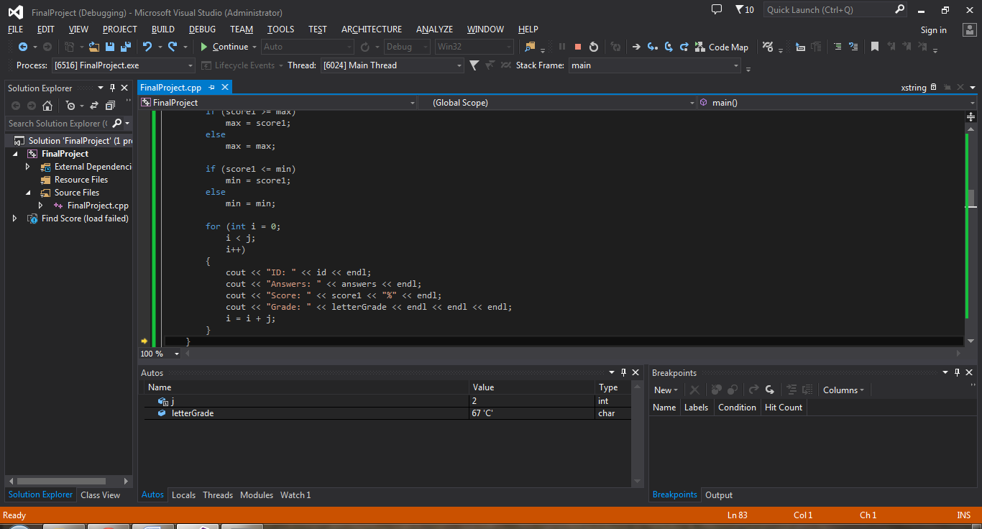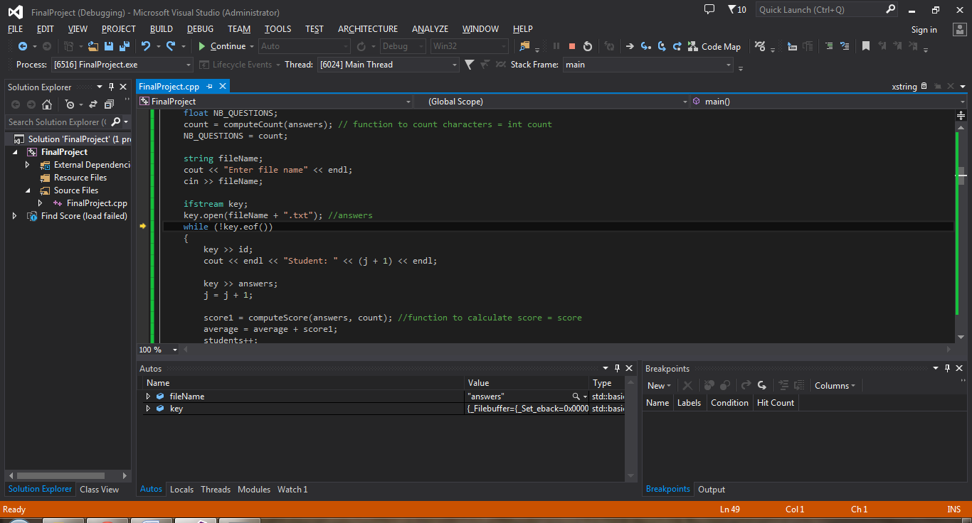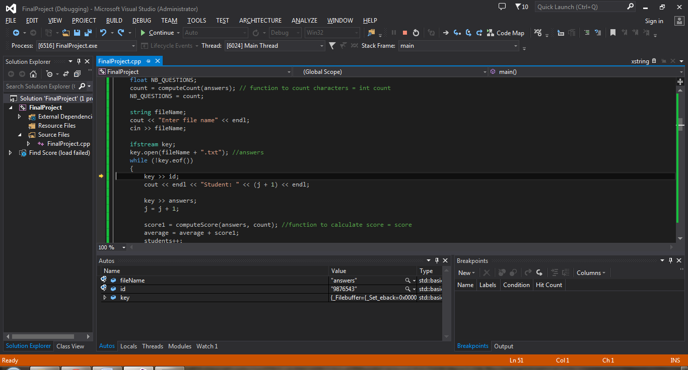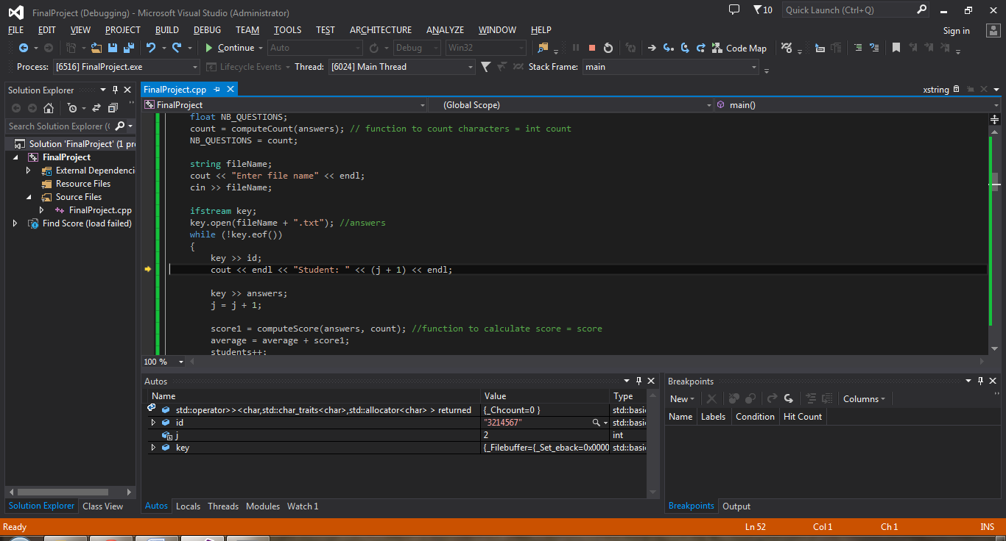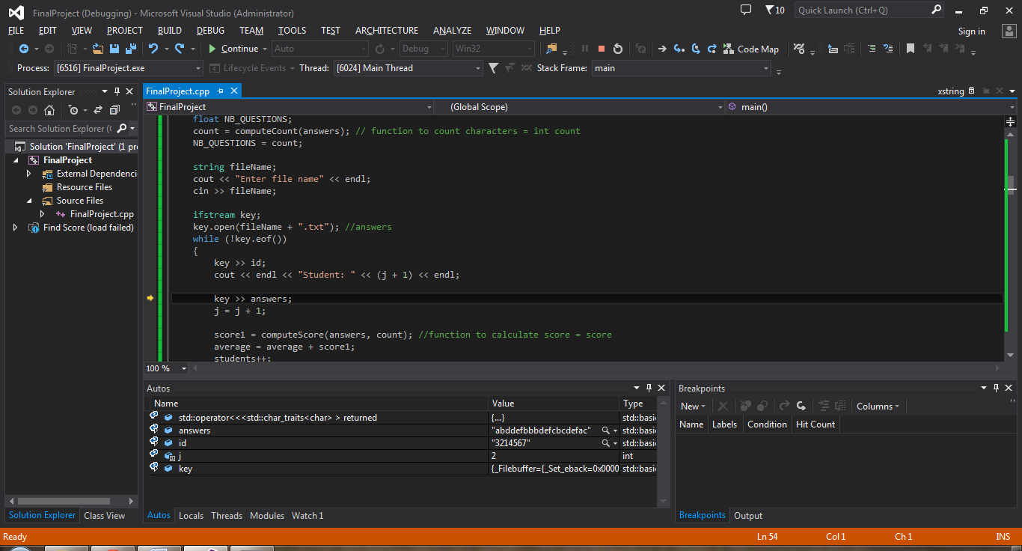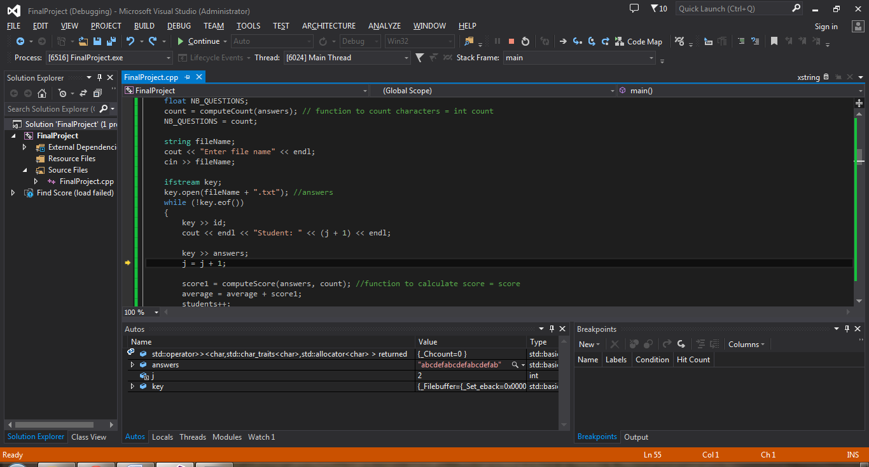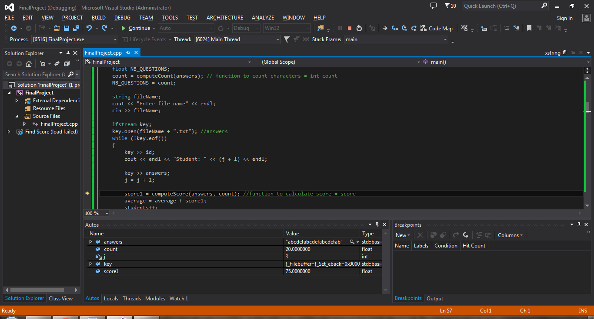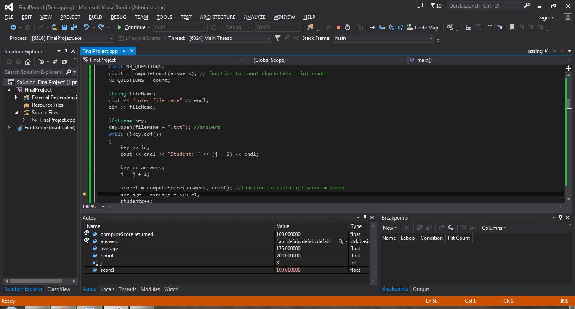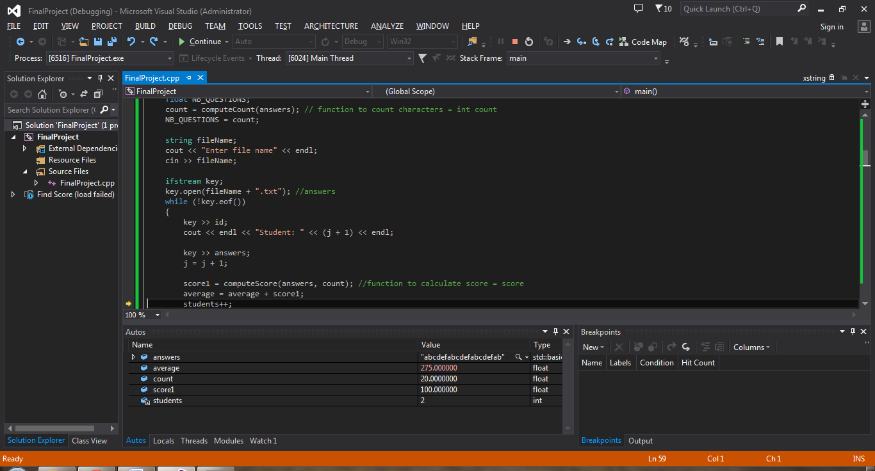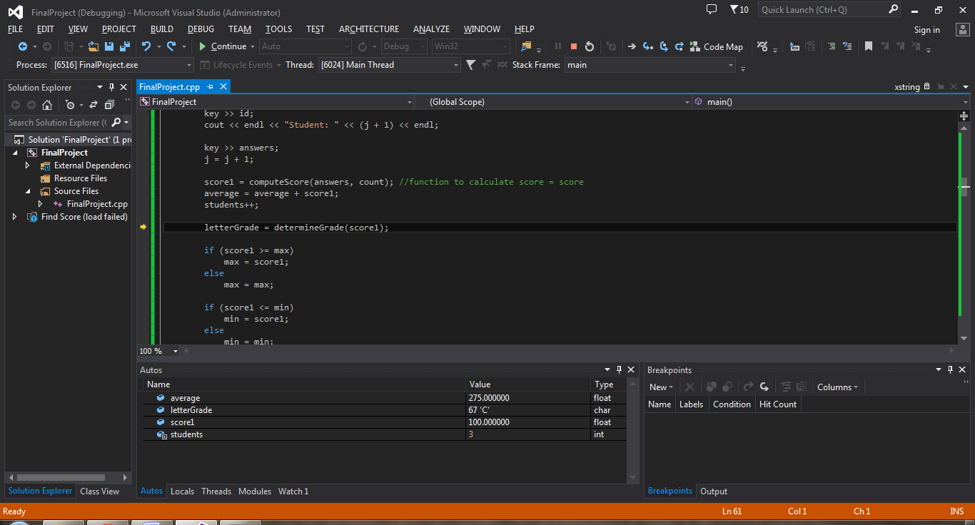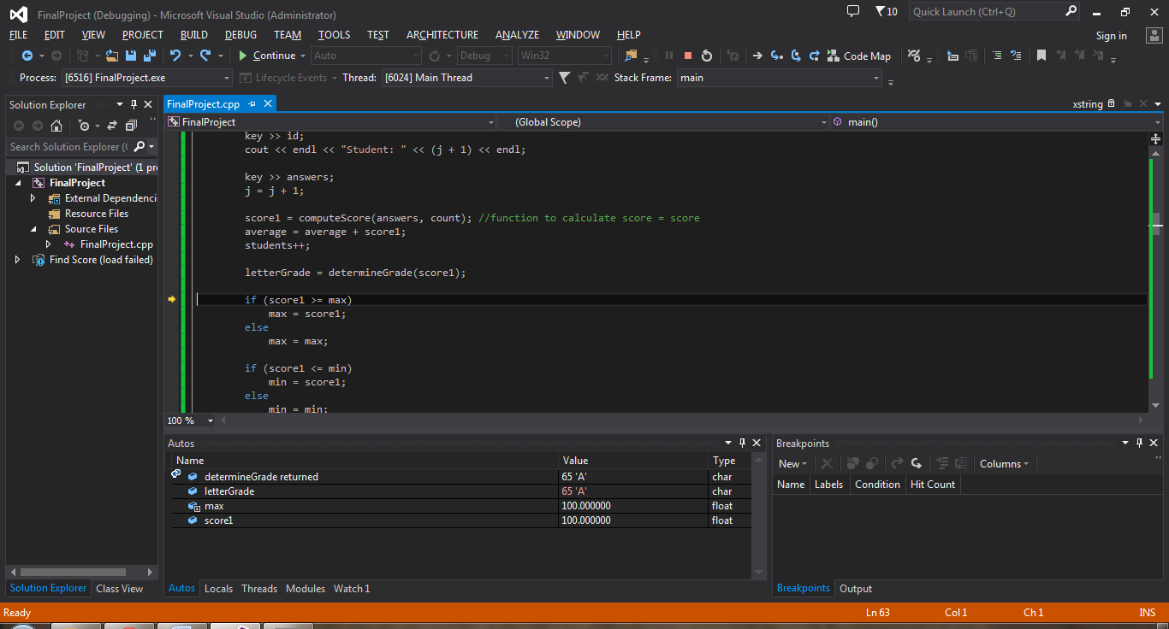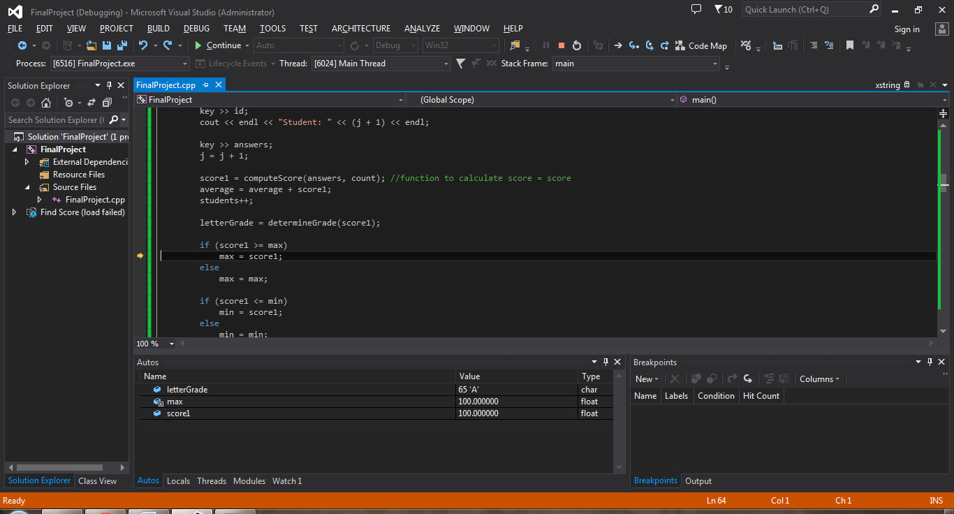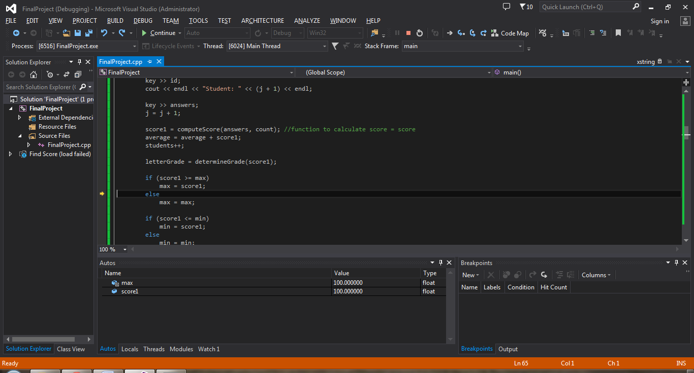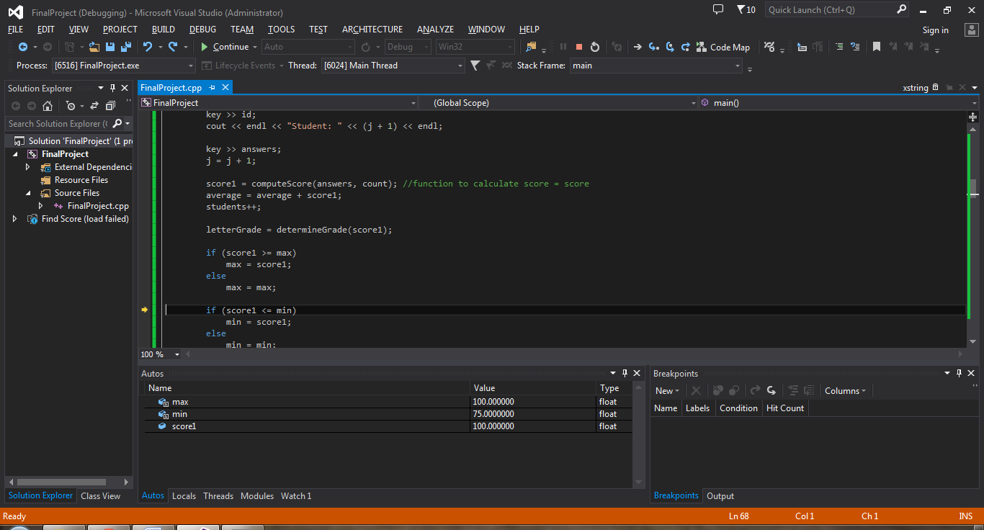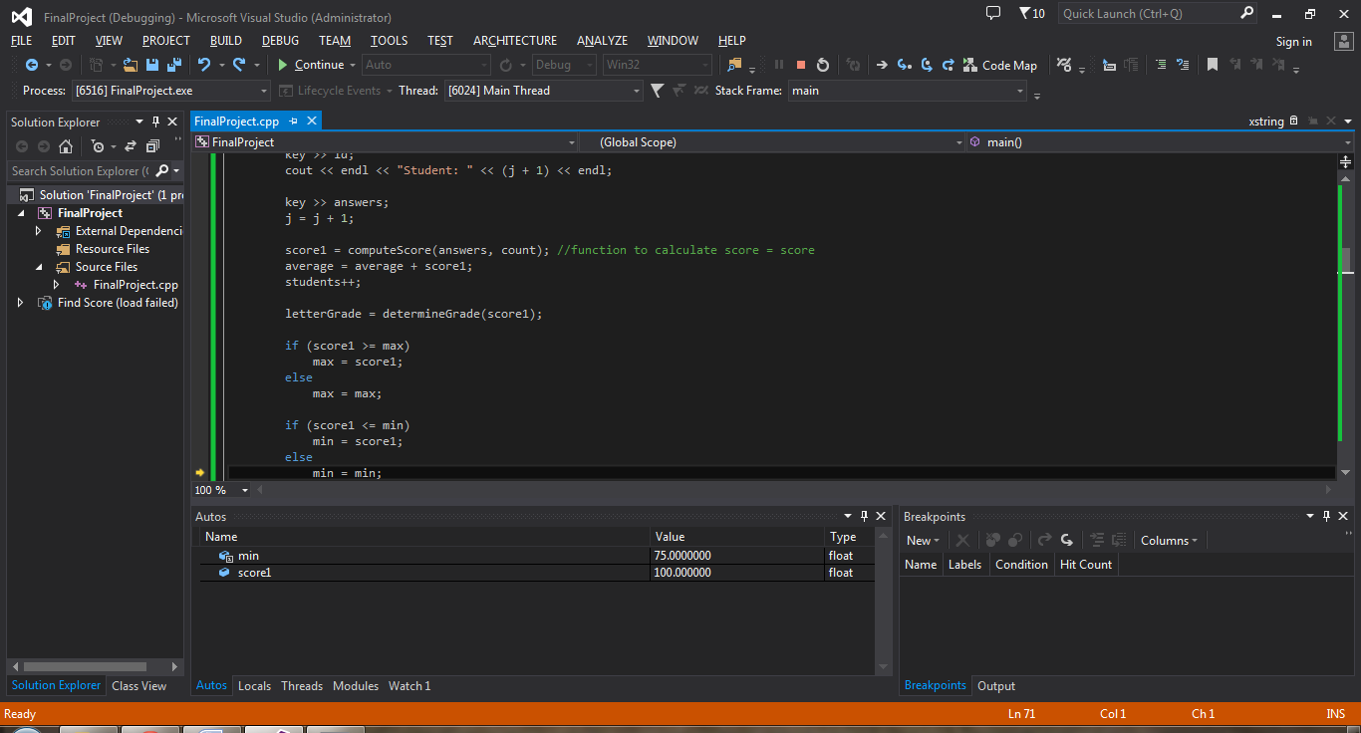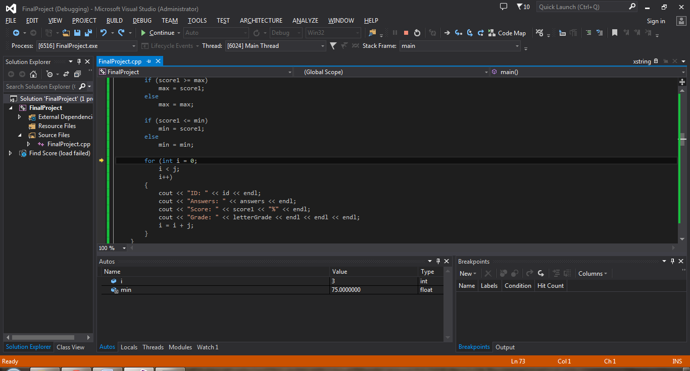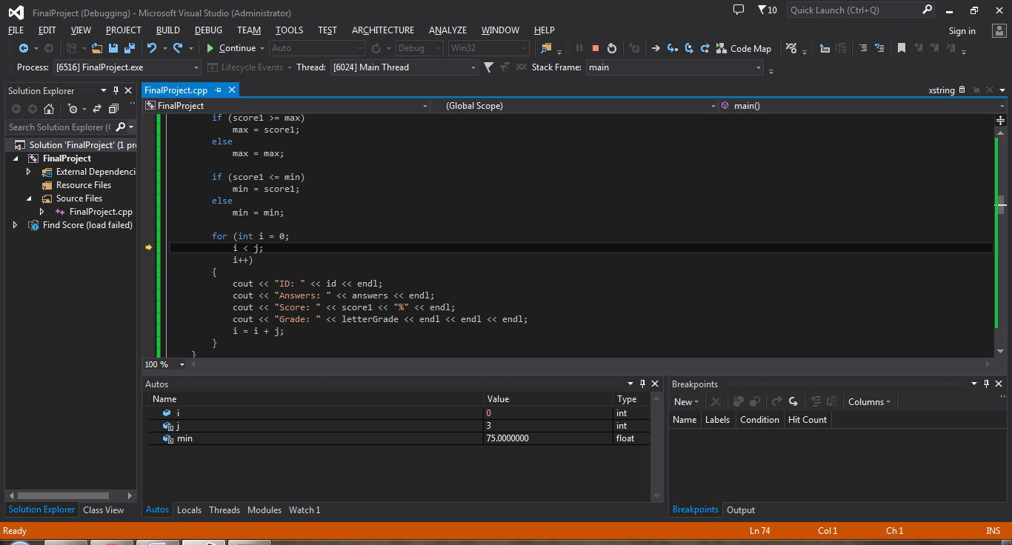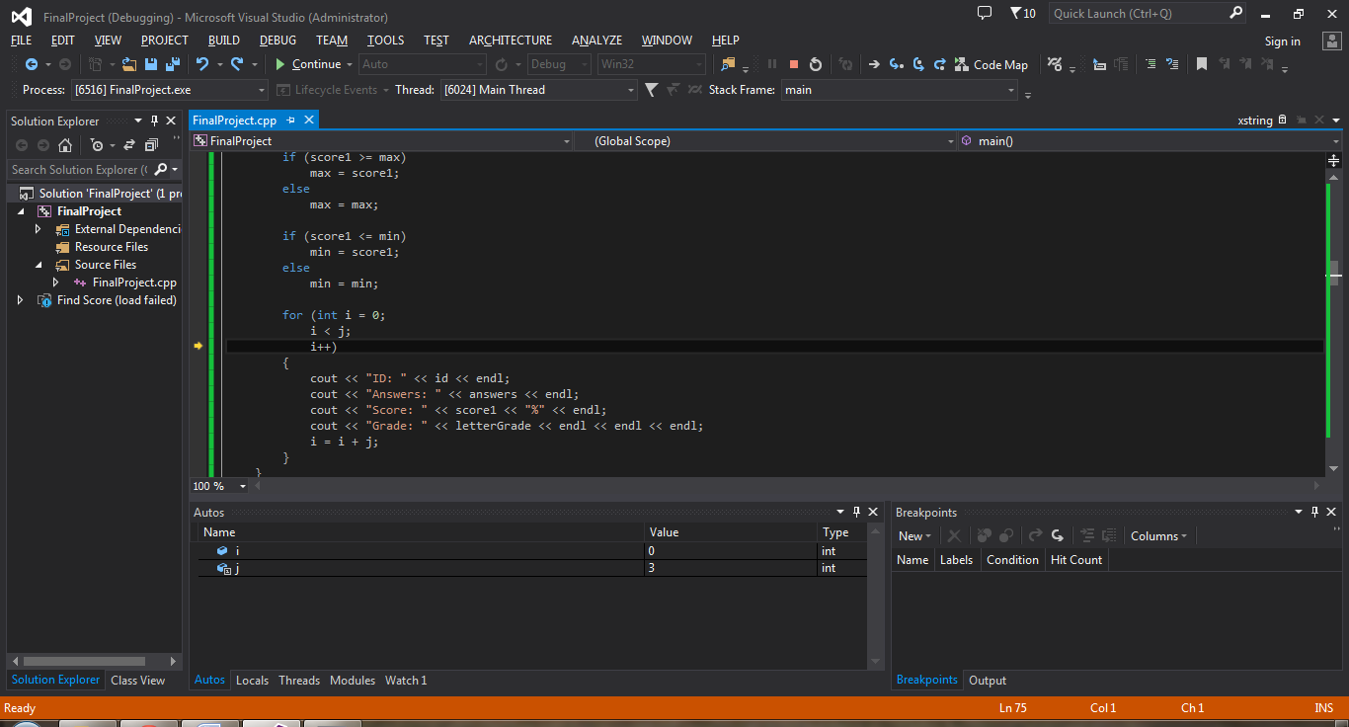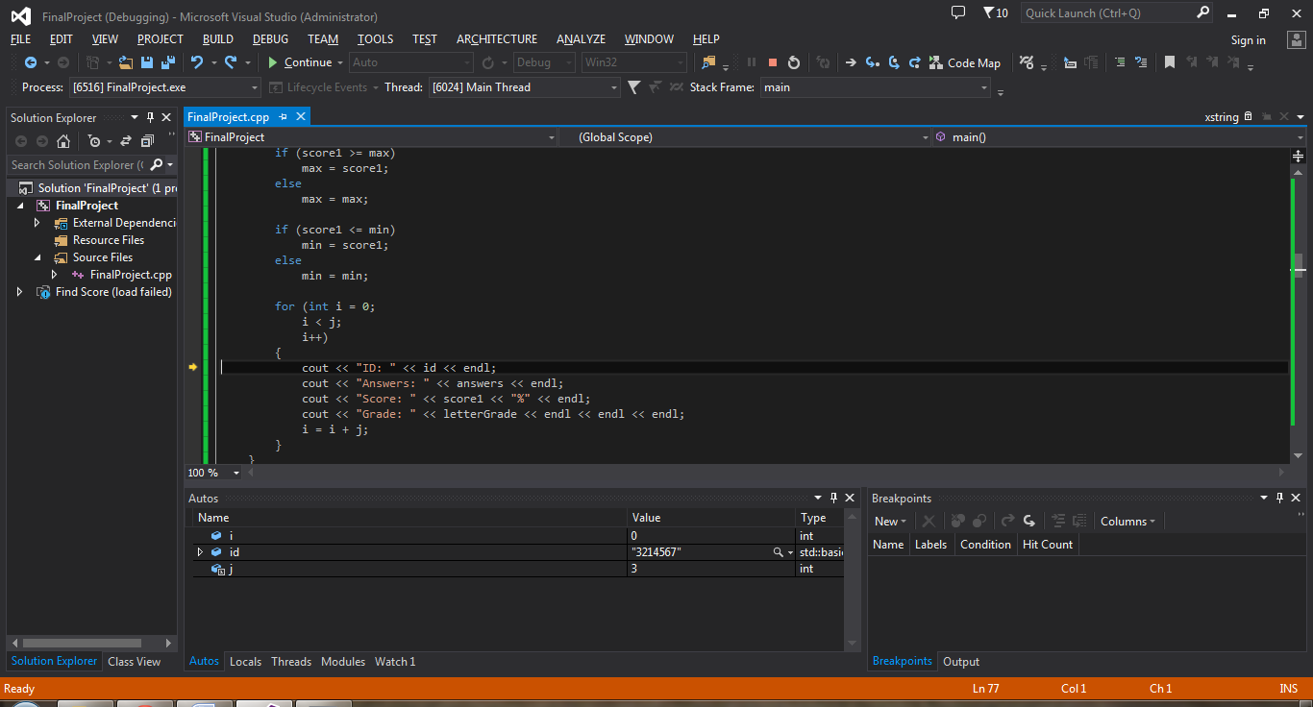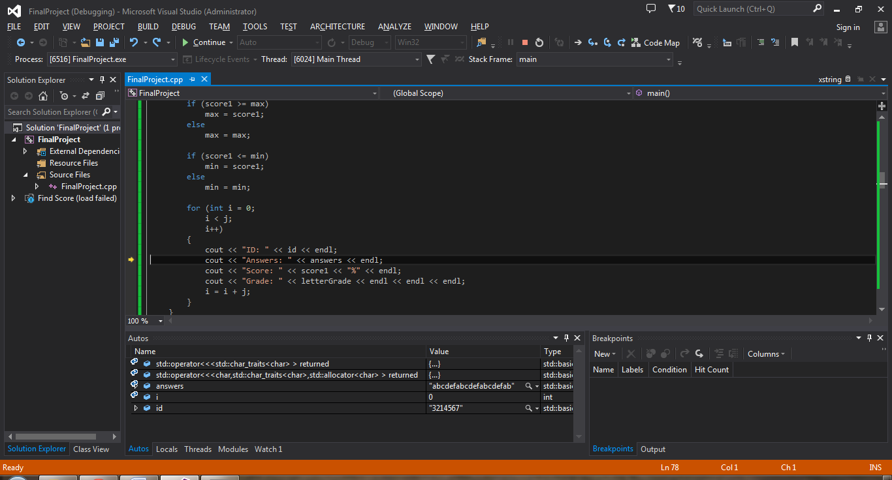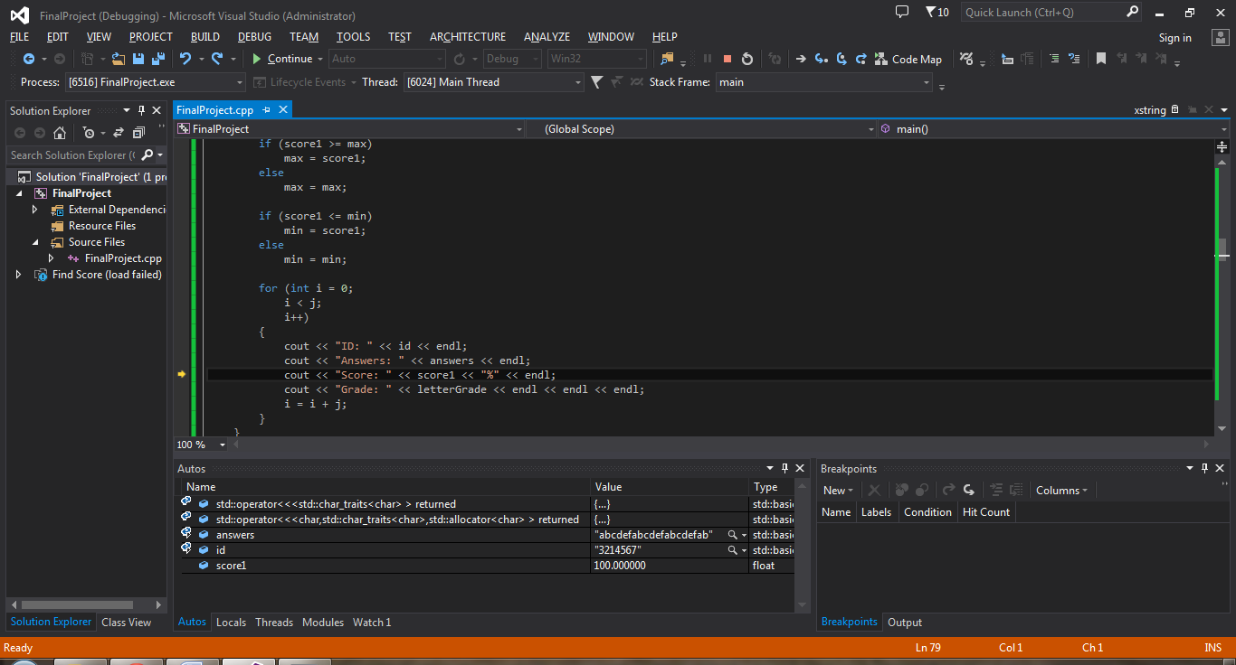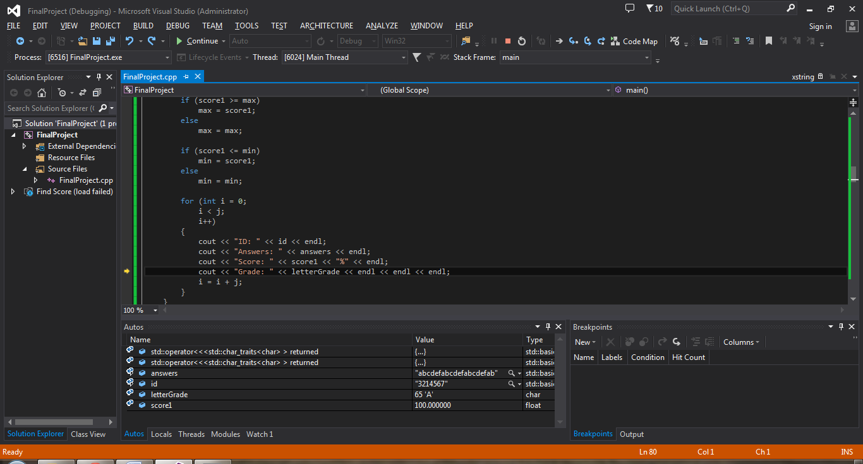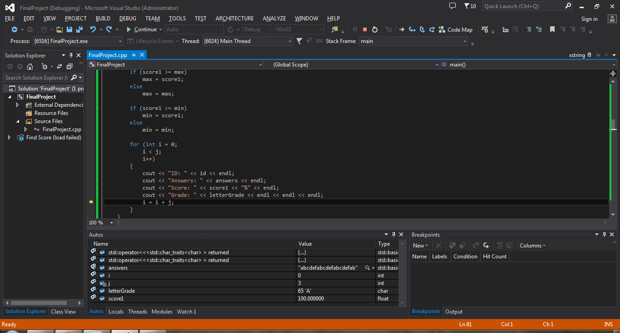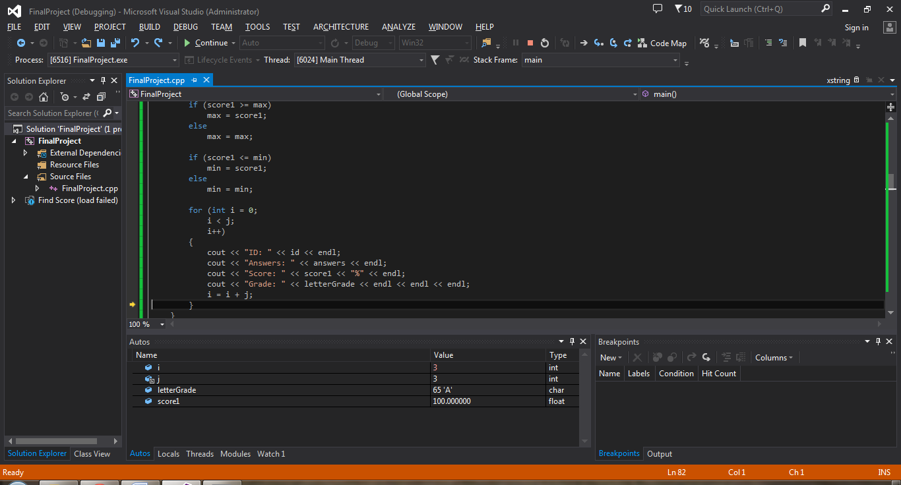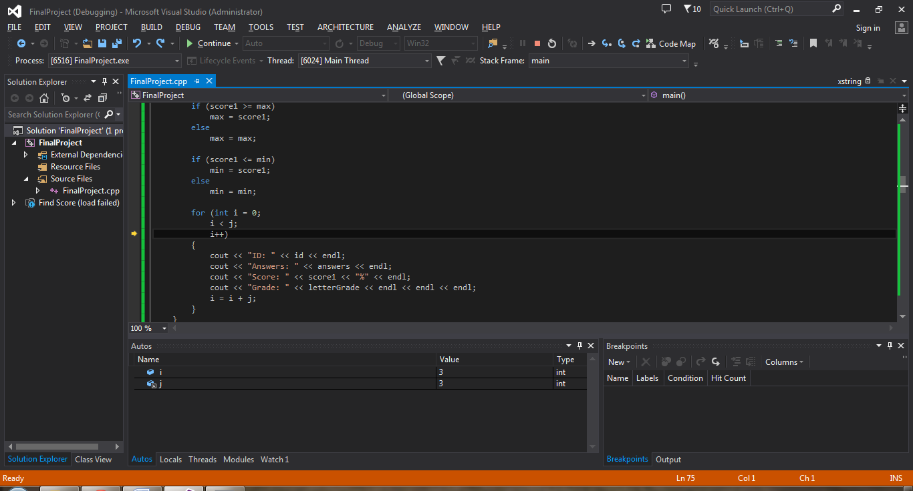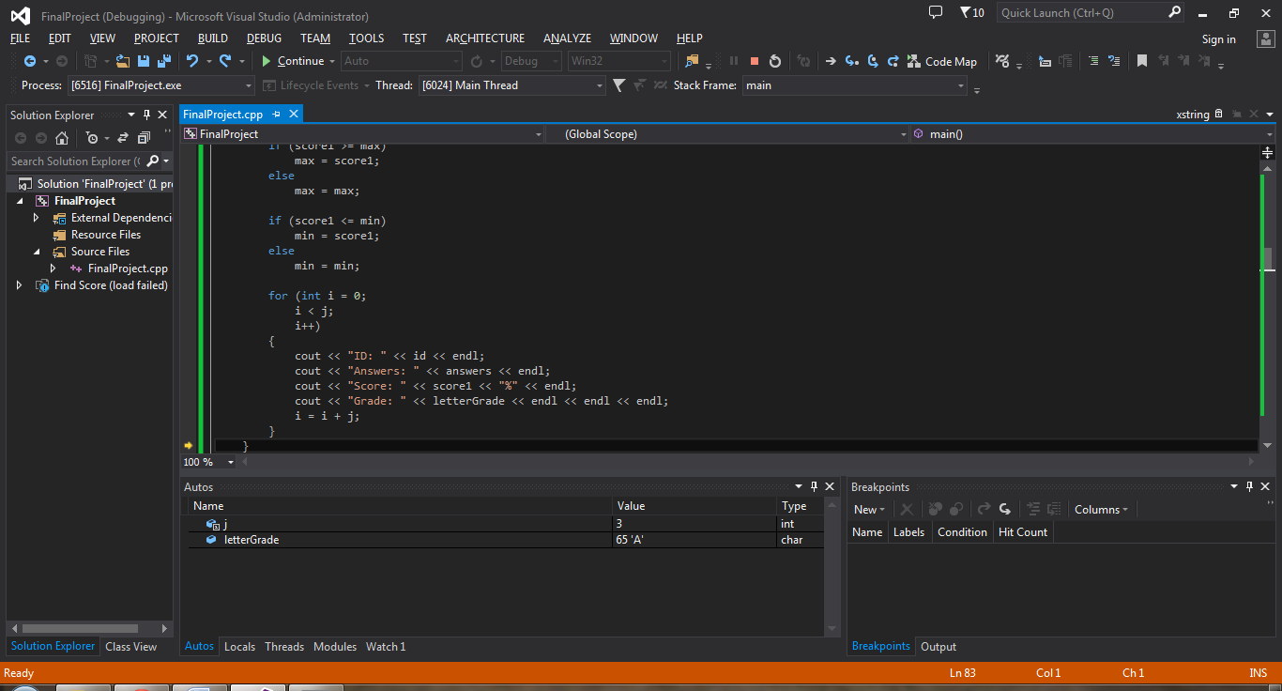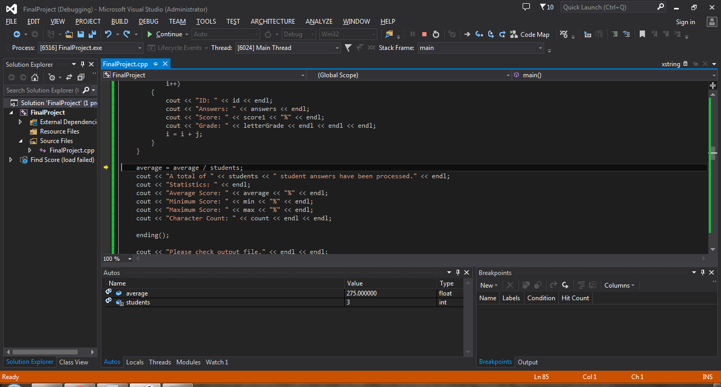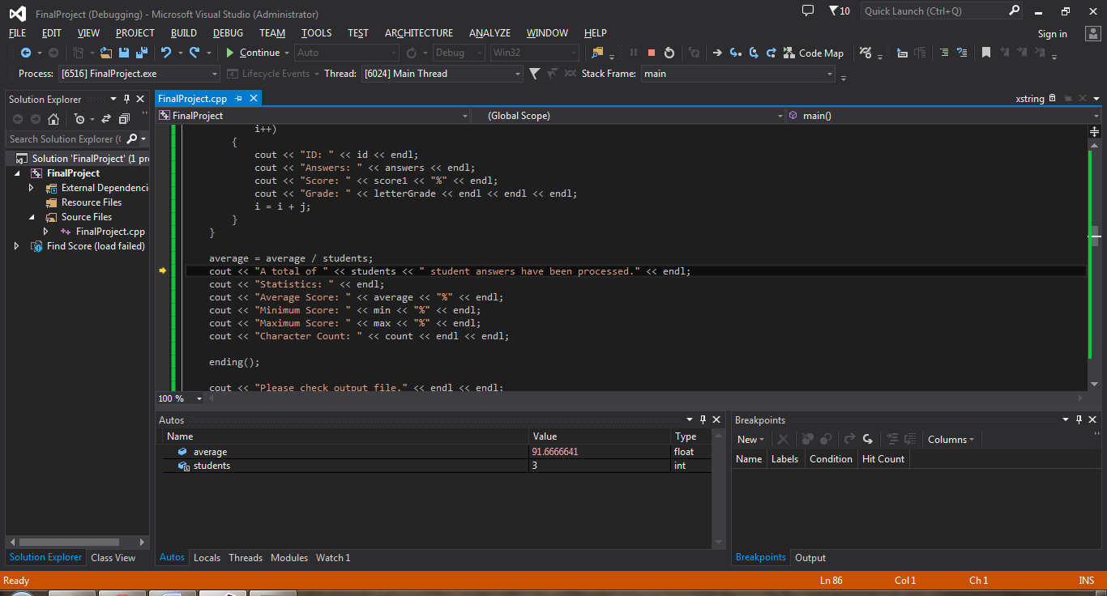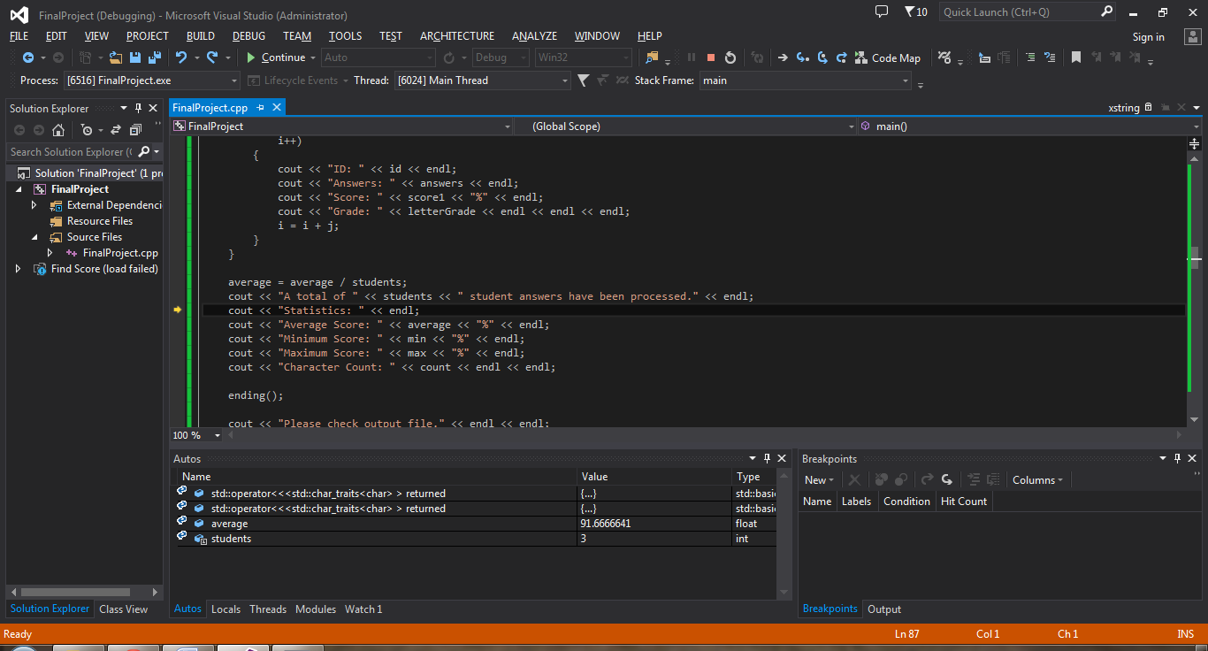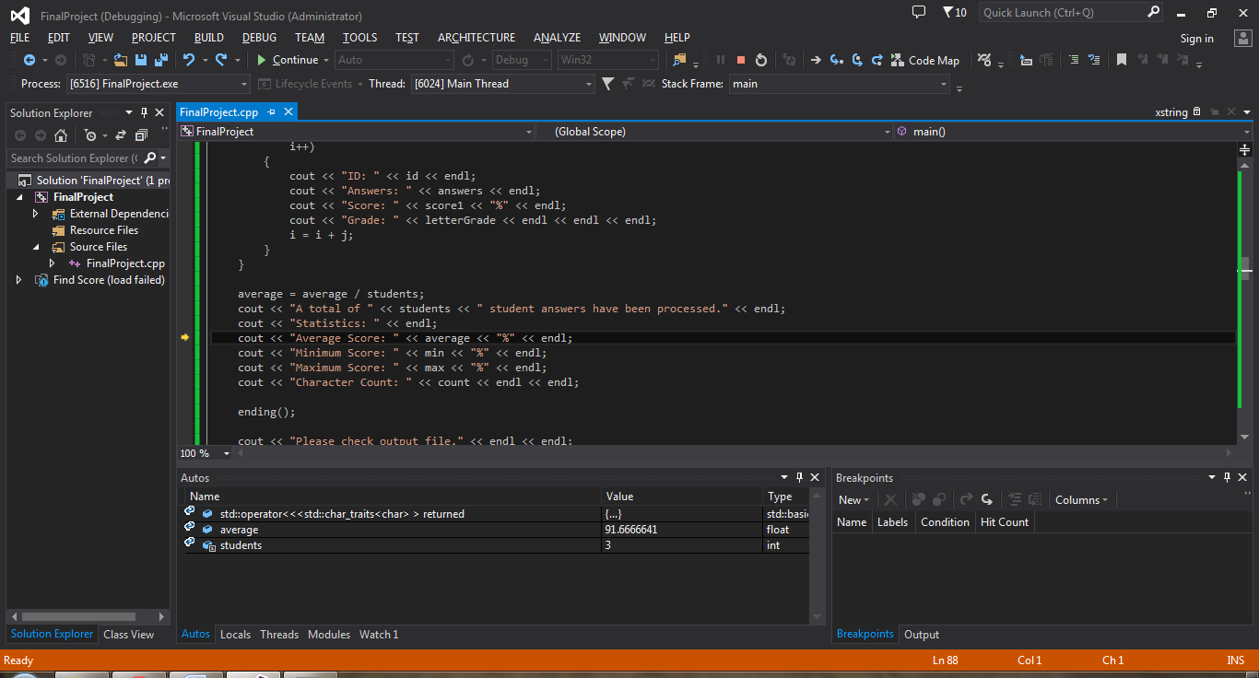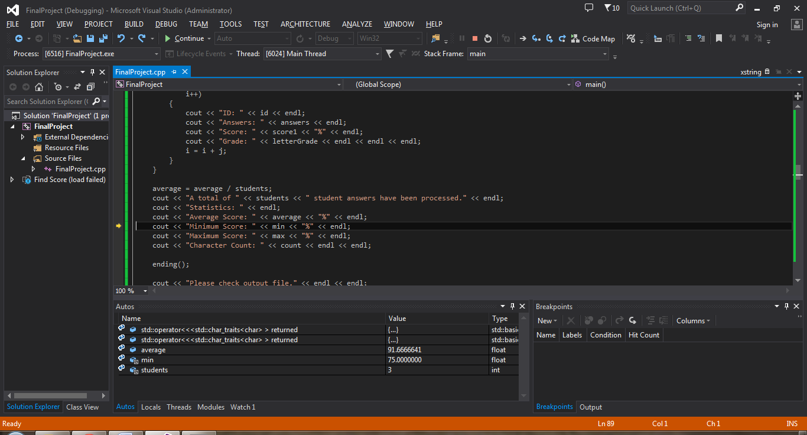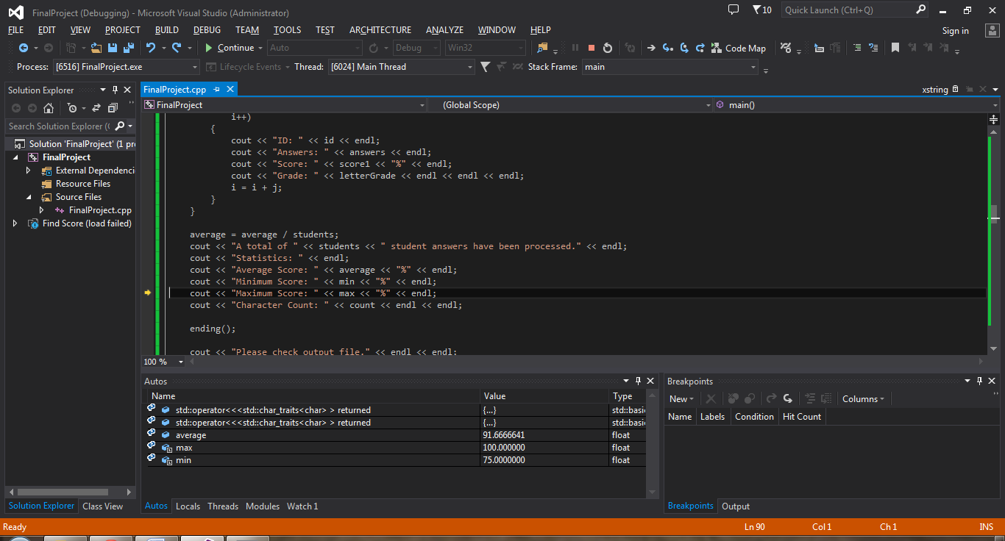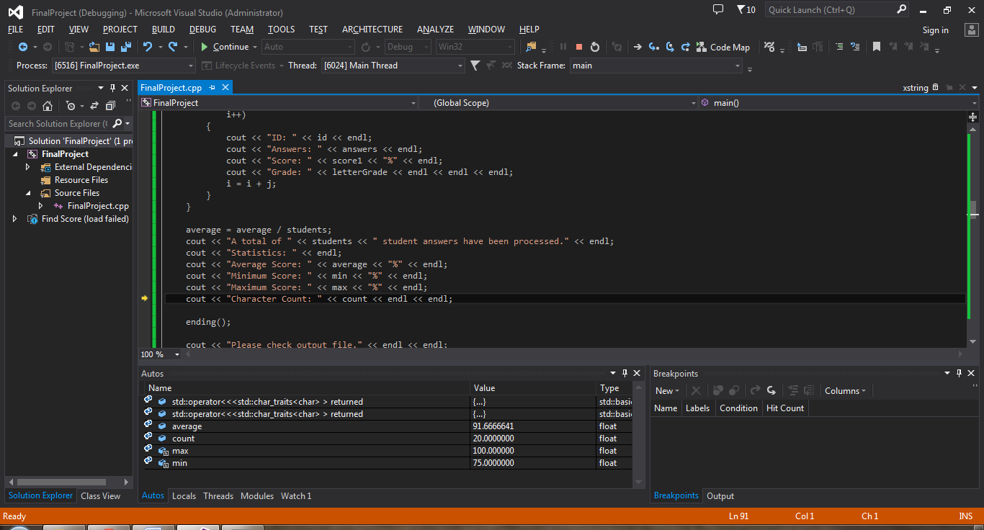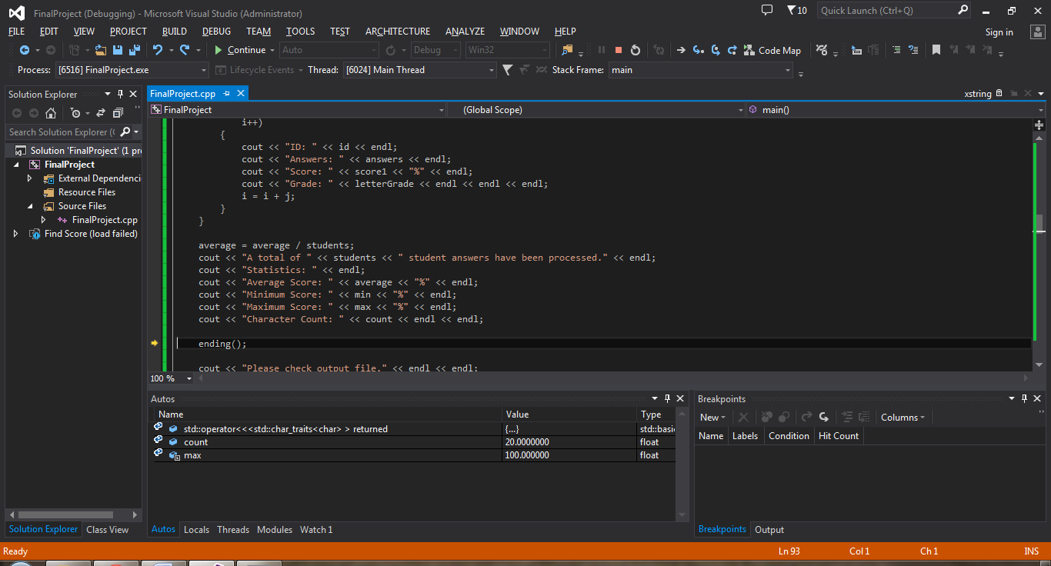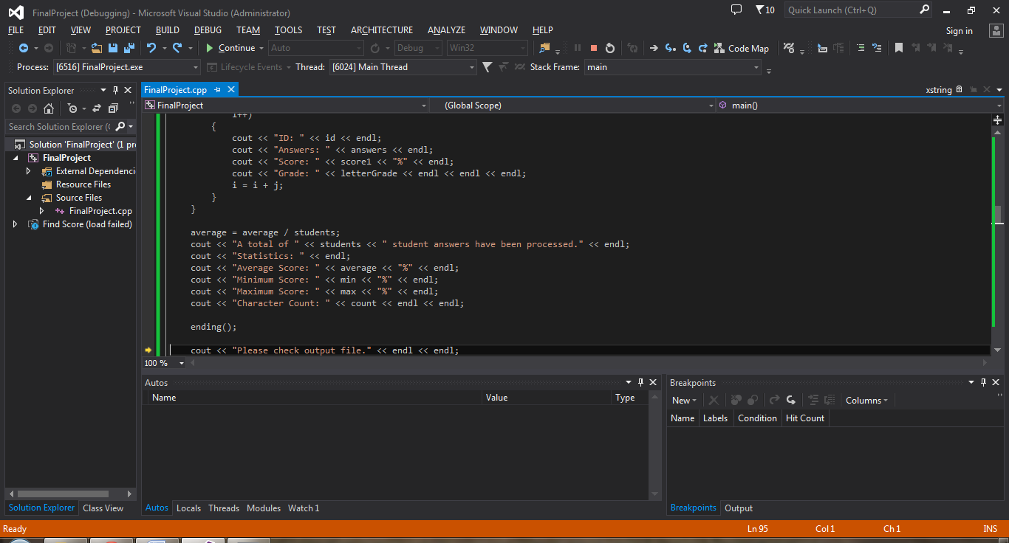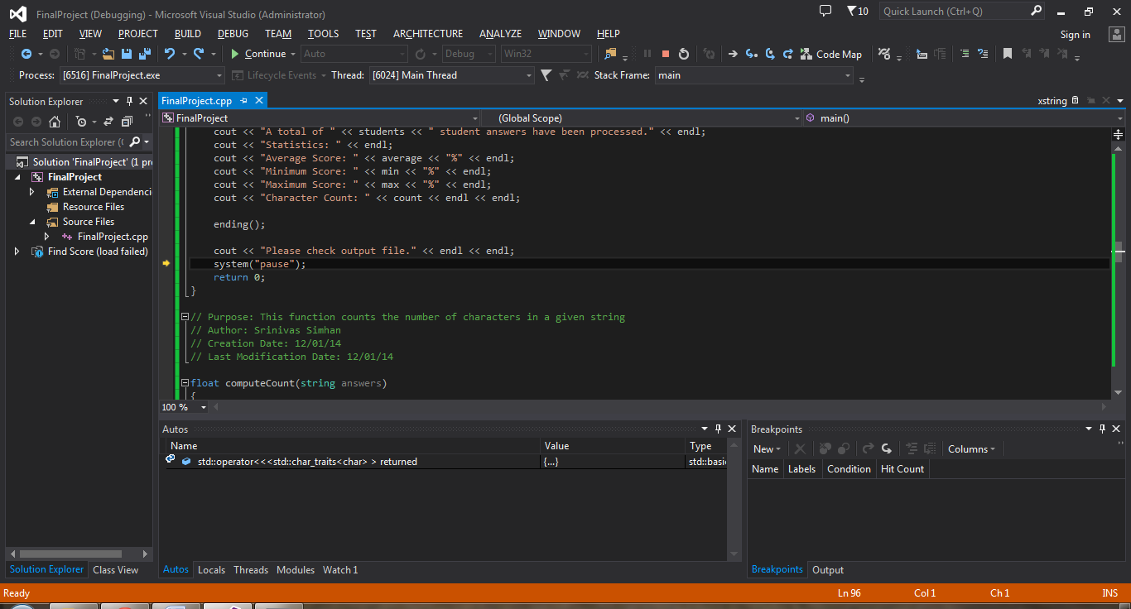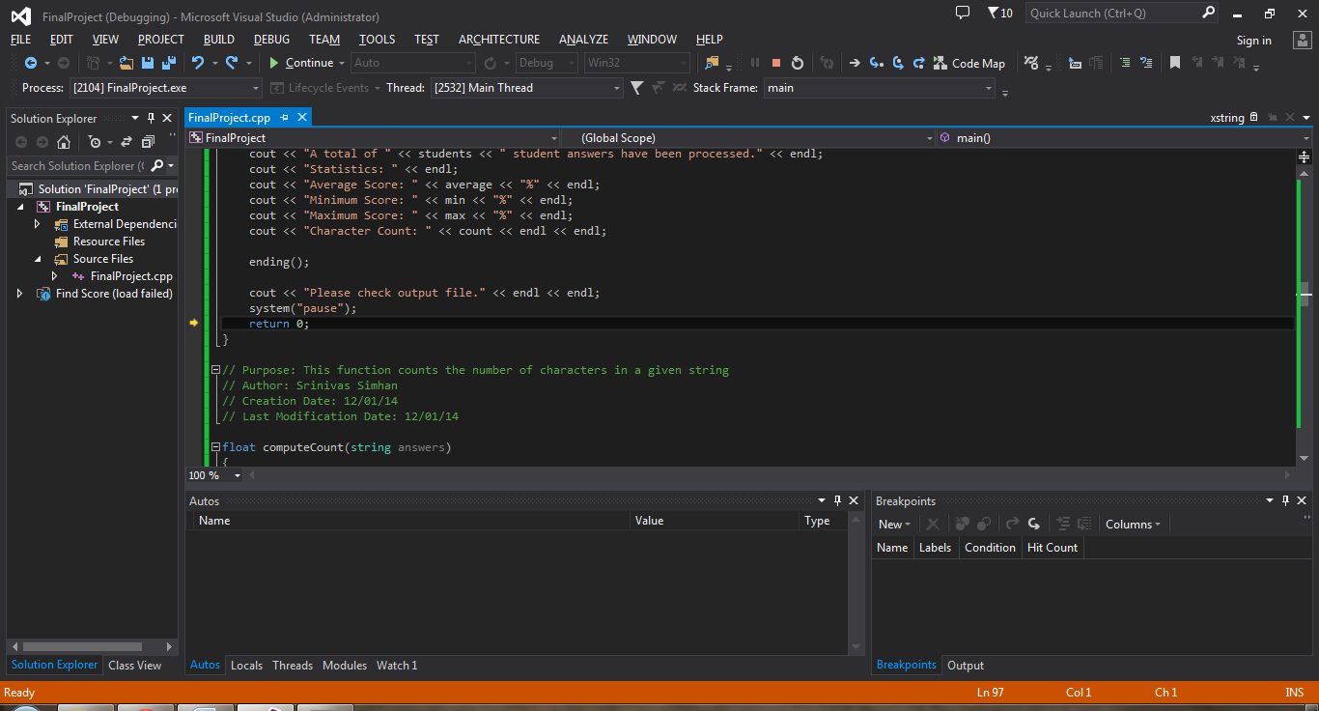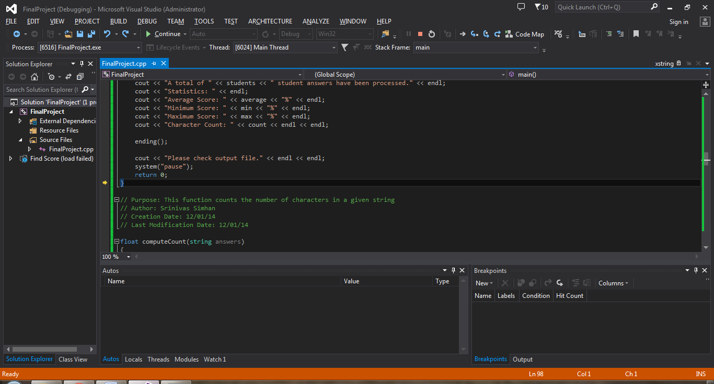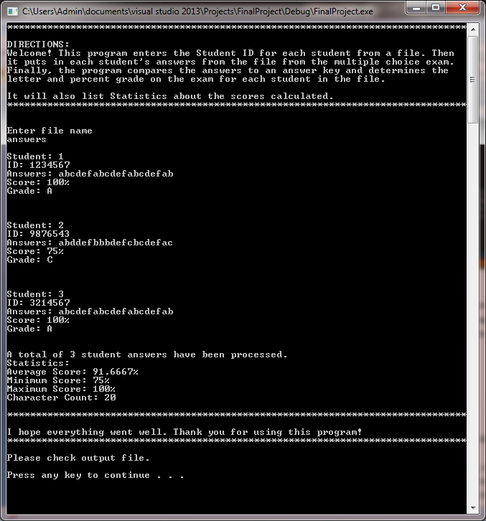

1. **Extra Credit 1: Results in Output File**

**5.1 How? (Code Included)**

I added code to open a new text file to output the information into. Then I also changed several “cout” functions to the variable that accessed the output file. This allowed me to output the chosen information that originally went to the Console onto the Text File.

Open File:

ofstream outFile("output.txt");

Output Information:

outFile << " ***: " << ** << endl;

1. **Extra Credit 2: Read Answer Key String from a Text File Instead of as a Constant String**

**6.1 How? (Code Included)**

I added code to read the Answer Key as a string from a chosen Text File, rather than as a “const string”, which is how I called it originally. It calls the string from the Text File and then compares it to the Students’ Answers that were called from a different Text File. It then computes the score and returns the score value.

Before:

const string ANSWER_KEY = "abcdefabcdefabcdefab";

After:

float computeScore(string answers, int NB_QUESTIONS)

{

string ANSWER_KEY;

ifstream student;

student.open("answerString.txt");

while (!student.eof())

{

student >> ANSWER_KEY;

float score;

int correct = 0;

for (int i = 0;

i < NB_QUESTIONS;

i++)

{

if (ANSWER_KEY.at(i) == answers.at(i))

{

correct++;

}

}

score = (correct * 100) / NB_QUESTIONS;

return score;

}

}

1. **Extra Credit 3: Enter Name of File that Contains Students’ Answers**

**7.1 How? (Code Included)**

It displays on the Console “Enter file name: “ and adds “.txt” to the end of it, then plugs the Text file name into the code so that it can be read and used in the Main Source Code. It then proceeds to follow normal code procedures.

string fileName;

cout << "Enter file name: " << endl;

cin >> fileName;

ifstream key;

key.open(fileName + ".txt"); //type answers to put "answers.txt" into the program